**Stress-Free Compliance**

The Environmental Health and Safety (EHS) Online Training System is an interactive web site that allows staff, faculty and students to take required federal occupational standards instruction and assessment online. The Emerging Technology Center (ETC) at ETSU designed and developed the system to assist TBR institutions in training their employees and others efficiently and support compliance with TOSHA standards while getting an excellent return on their investment. The EHS Online Training System offers

* Ease of administration
* Full-featured reporting
* Integrated security
* Support for implementing industry Best Management Practices

Why should your workers be trained? The Tennessee Occupational Safety & Health Administration gives the following reasons:

**It's good business**

The direct costs of accidents and injury in the workplace include the medical costs associated with the incidents and workers compensation costs. However, there are a multitude of indirect costs that make up the bulk of the losses. These include the costs of loss of workers (replacement/training), spoiled product, damaged equipment, legal/clerical fees, disruption of workforce, and others. A single accident can cost a company as much as $3000, and if the same accident involves legal fees, the cost can climb to $10,000.

**It's the right thing to do**

No one wants to see their employees and co-workers injured on the job. Lives and families can be destroyed in a few minutes when a workplace injury, illness, or fatality occurs. Training may not solve all problems and may not prevent all accidents resulting in workplace injuries and illnesses, but failure to have an effective training program is a component of most accidents.

**It's the law**

TOSHA standards and regulations that have training requirements are LAW. Failure to comply with the training requirements can result in citations and civil penalties from TOSHA.

*Source: http://www.tn.gov/labor-wfd/TrainingGuidelines.pdf*

**Ease of Use & Administration**

Your trainees will have no trouble using this system; minimal computer skills are required. Users log in to the system with their Banner login credentials making it easy to access training materials while remaining secure from outside intrusion. Your trainees are provided with safety training materials on specific subjects–that you assign to them–and are allowed to review the material and take a quiz when they are ready. Several training modules are provided in the initial system set up and more can be added by the ETC. The training modules are available 24-7, year-round.

Easy Uploads

On the administrative end, it’s easy to pre-populate the database with users’ names and assigned training by simply uploading a spreadsheet file. When a user completes a training module, takes the test, and submits the answers, the date and score are stored in a database. The administrator can also print training certificates for any user as well as update user or group data.

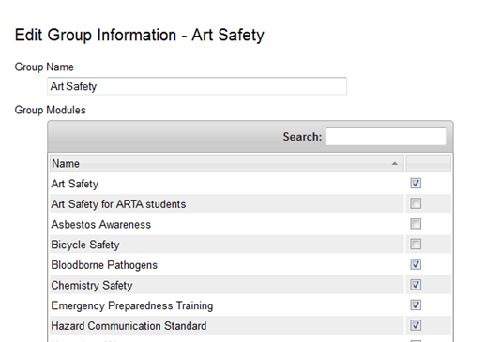

**Full-Featured Reporting**

The system produces comprehensive reports on users, dates, and completed tests and scores; the reports are provided online and in Microsoft Excel format.

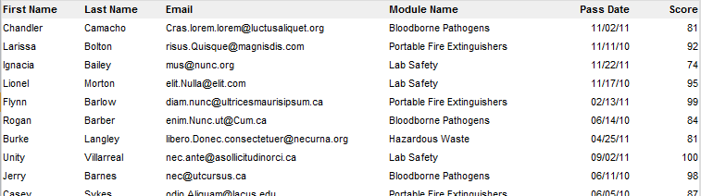

Administrators can run numerous reports pertaining to training completion status. The training information is sortable by multiple data points, including department, date, training modules, and group.

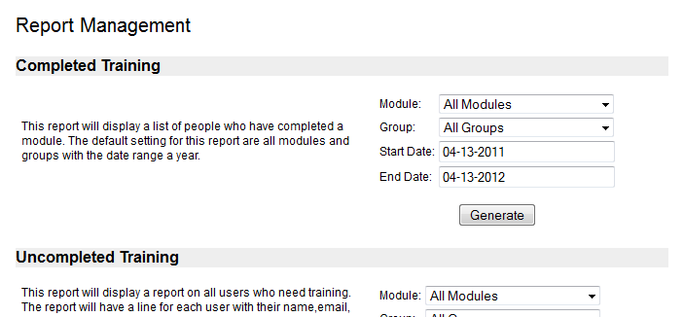

We tailor system features to your school’s needs to maximize reporting benefits. Some of the reporting possibilities include the following:

Customizable Reports

* Individual user histories that detail testing progress and grades
* List of users who have completed a module filtered by date range
* Condensed report of users that need to complete training
* Reports showing users who have or have not logged into the system for a specified time period

**Integrated Security**

The ETC works closely with your school’s IT department to assure the training site is integrated with users’ Banner login databases and meets security standards.

To access the system, trainees are sent an email that directs them to a login page on their school’s environmental health and safety web site; the system always adheres to your school’s current security policies.

Multiple Levels of Security

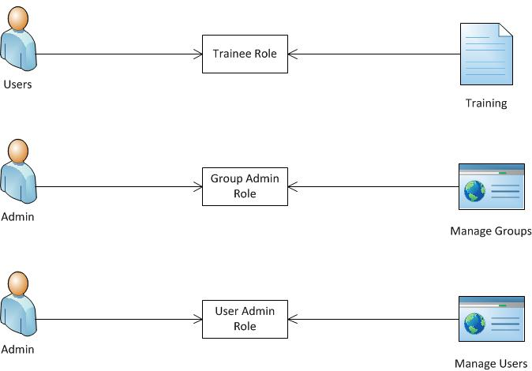

**What our clients say…**

“For the last two years at MTSU, I have had the pleasure and opportunity to work very closely with Carolyn Novak and her excellent team at the Emerging Technology Center at ETSU. Carolyn and her team are extremely professional, responsive, service oriented and easy to communicate with in person, by email or conference calls. In a word, I would use excellence to describe their work and work products.”

*— Doug Brinsko, Associate Director-EHS, MTSU*

“We have found using this system to be the best way to meet our training requirements with little resources.” *— Dan O’Brien, Director of EHS, ETSU*

**For more information, please contact:**

Carolyn Novak, Director, Emerging Technology Center

Department of Computer and Information Sciences

East Tennessee State University

Phone: (423) 439-5824

Email: novak@etsu.edu