

Tennessee Board of Regents

2016

Benefits Guide

The Tennessee Board of Regents is the nation’s sixth largest higher education system, governing 46 post-secondary educational institutions. The TBR system includes 6 universities, 13 two-year colleges, and 27 colleges of applied technology, providing programs in 90 of Tennessee’s 95 counties to more than 200,000 students.

letter to employees

Dear Tennessee Board of Regents (Higher Education) Employee,

It is our pleasure to announce the Tennessee Board of Regents’ and the State of Tennessee’s Open Enrollment/Annual Enrollment Transfer Periods will again run concurrently. The dates of this period are September 15 – October 15.

As a higher education employee, you are eligible to participate in insurance plans offered by both the State and Tennessee Board of Regents. In some instances, such as the Flexible Spending Account and Employee Sick Leave Bank, higher education employees are only eligible to participate in the Tennessee Board of Regents’ plan.

At your request, your Benefits Representative will also provide enrollment and change information for the 401(k), 457, and 403(b) plans. While higher education employees are eligible to enroll and/or make changes to contributions levels at any time during the plan year, many employees choose to complete these tasks during the annual enrollment period. This is also an excellent time to review and/or update your beneficiaries for all applicable benefits.

***IMPORTANT INFORMATION ABOUT VOLUNTARY VISION INSURANCE***

The Tennessee Board of Regents offers both the TBR – VSP plan and the State EyeMed Plan.

Employees Currently Enrolled in the TBR – VSP Vision Plan:

To remain in the TBR - VSP vision plan requires no action on your part. If you make changes to your health and dental plans, simply “decline or waive” the State’s vision coverage in Edison.

To switch to the State’s vision plan, you must 1) enroll using the State’s Employee Self Service (ESS) in Edison, even if you do not make changes to your health or dental plans and 2) contact your HR Department to cancel coverage under the TBR – VSP Vision Plan.

Employees Currently Enrolled in the State EyeMed Vision Plan:

To remain in the State’s vision plan at the current coverage level requires no action on your part.

To enroll in the TBR — VSP vision plan, visit www.tbrbenefits.com and complete the online enrollment process. If you wish to cancel the State’s EyeMed vision plan login to Edison using (ESS) and choose “decline or waive”.

Employees NOT Currently Enrolled in Either Vision Plan:

To enroll in the State’s vision plan requires that you enroll on the State’s Employee Self Service (ESS) System. Even if you are not making changes to your health or dental plans you will need to access ESS to complete your vision enrollment.

To enroll in the TBR — VSP vision plan, visit www.tbrbenefits.com and complete the online enrollment process.

The Tennessee Board of Regents recognizes benefits as an important part of your total compensation package. Please take the time to review your choices and select the benefits most beneficial for you and your family.

Sincerely,
Tennessee Board of Regents

GET AQUAINTED with state sponsored benefits

- Enrollment Period – STATE of TN – September 15th through October 15th
  - Health – BCBSTN, Cigna,
  - Dental – Cigna Prepaid, MetLife PDO
  - Vision – EyeMed
  - Optional Group Term Life Insurance – Minnesota Life
  - Long Term Care – MedAmerica

(Mailed directly to each employee’s home address by the State’s Benefits Administration team)

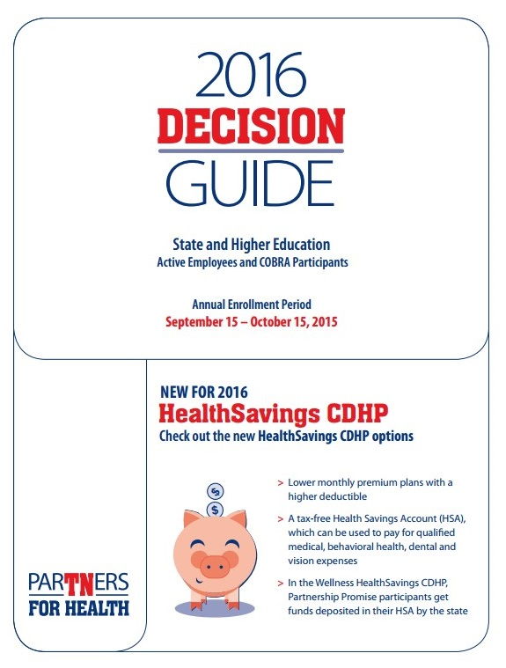

wHAT YOU NEED TO KNOW ABOUT ESS

If you DO NOT want to make changes to your current State sponsored benefits, NO ACTION is required.

However, if you DO want to make changes to your State sponsored benefits, you must do so online using employee self- service (ESS) in Edison, the State’s business software. The State no longer accepts paper forms during Open Enrollment. Detailed instructions were provided in the State’s Decision Guide. For your convenience, excerpts of these instructions are provided on the following page.

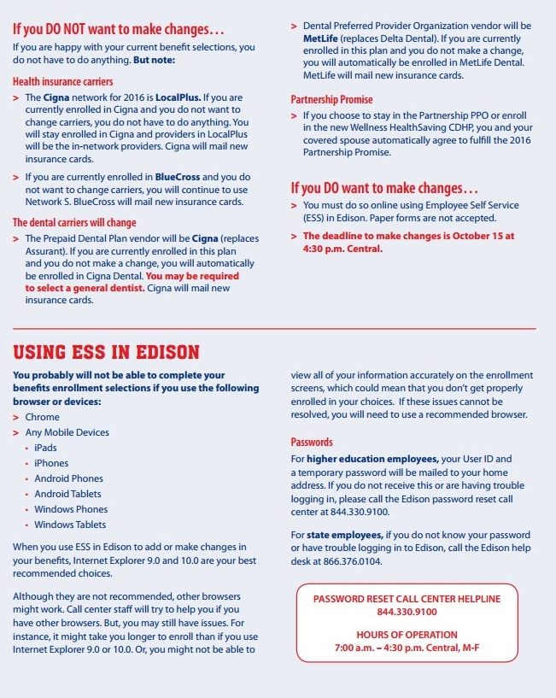

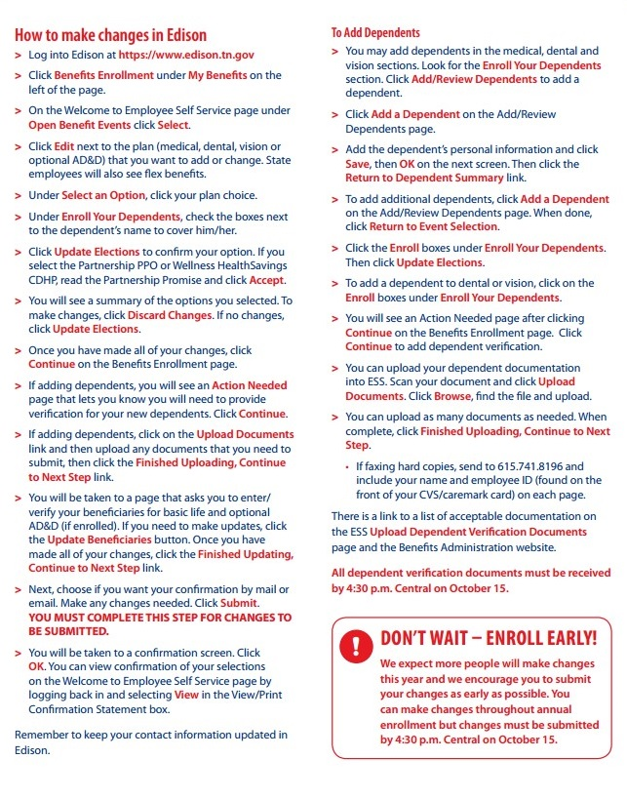
STATE of tennessee – ENROLLMENT PERIOD

MEDICAL

Health insurance premiums will increase 3.5% in 2016. Eligible employees will continue to have a choice of two insurance carriers, Blue Cross Blue Shield and Cigna. Please note the following IMPORTANT information regarding the carrier networks:

- Blue Cross Blue Shield – S Network will remain in place
- Cigna Open Access Network will no longer be available effective January 1, 2016
- All employees enrolling or remaining in Cigna will automatically be placed in the Cigna Local Plus Network

*Note: Please refer to the State’s Decision Guide for specific network information.

Eligible employees will continue to have a choice of participating in the Partnership PPO or Standard PPO. In addition, employees will now have a 3rd and 4th option. The new offerings, called Consumer Driven Health Plans (CDHP), have a lower monthly premium with a higher deductible and include a health savings account (HSA).

*Note: Please refer to the State’s Decision Guide for additional information about CDHP/HSAs.

PPO PLANS

Option 1

Partnership PPO – employees participating in the partnership option will benefit from lower premiums, co-pays, and coinsurance costs. This option requires a commitment to complete the 2016 Partnership Promise.

  - Blue Cross Blue Shield of Tennessee – S Network
  - Cigna Local Plus

Partnership PPO - Employee Health Premiums (monthly)
Coverage Level | BCBST or Cigna Local Plus
Employee Only | $118.50
Employee + Child(ren) | $177.74
Employee + Spouse | $248.84
Employee + Spouse + Child(ren) | $308.09

Option 2

Standard PPO – employees participating in the standard option are not required to complete the 2016 Partnership Promise.

  - Blue Cross Blue Shield of Tennessee – S Network
  - Cigna Local Plus

Standard - Employee Health Premiums (monthly)
Coverage Level | BCBST or Cigna Local Plus
Employee Only | $143.50
Employee + Child(ren) | $202.74
Employee + Spouse | $298.84
Employee + Spouse + Child(ren) | $358.09

CDHP/HSA PLANS

Option 3

Wellness HealthSavings CDHP – employees participating in the Wellness option will benefit from lower deductibles, out-of-pocket maximums, and coinsurance costs when compared to the HealthSavings CDHP without Wellness. In addition, Wellness participants will receive an annual employer contribution to a HSA depending on coverage level. This option requires a commitment to complete the 2016 Partnership Promise.

  - Blue Cross Blue Shield of Tennessee – S Network
  - Cigna Local Plus

Wellness HealthSavings CDHP/HSA - Employee Health Premiums (monthly)
Coverage Type | BCBST or Cigna Local Plus | HSA Employer Contribution
Employee Only | $81.00 | $500.00
Employee + Child(ren) | $122.50 | $1,000.00
Employee + Spouse | $170.50 | $1,000.00
Employee + Spouse + Child(ren) | $212.00 | $1,000.00

Option 4

HealthSavings CDHP – employees participating in the HealthSavings (without Wellness) option are not required to complete the 2016 Partnership Promise. Participants enrolled in this option will not receive an annual employer contribution to a HSA, however, they may elect to contribute their own money to an HSA via payroll deductions or banking deposit transactions.

  - Blue Cross Blue Shield of Tennessee – S Network
  - Cigna Local Plus

HealthSavings CDHP - Employee Health Premiums (monthly)
Coverage Level | BCBST or Cigna Local Plus | HSA Employer Contribution
Employee Only | $81.00 | $0.00
Employee + Child(ren) | $122.50 | $0.00
Employee + Spouse | $170.50 | $0.00
Employee + Spouse + Child(ren) | $212.00 | $0.00

HEALTH SAVINGS ACCOUNT (HSA)

Employees who enroll in a CDHP can contribute money to a HSA account up to certain limits. The 2016 limits are $3,350 individual or $6,750 family (limits increase $1,000 at age 55 and older).

Employees who enroll in the Wellness CDHP and participate in the 2016 Partnership Promise will receive an employer contribution each year, deposited into the employee’s HSA, in the amount of $500 for employee and $1,000 for family. The amount of employer contributions are included in the annual limits provided above. Employees who enroll in the (non-wellness) CDHP do not receive an employer contribution but may elect to contribute to their HSA on a personal basis.

Employees DO NOT lose unused money. The money an employee saves in the HSA rolls over each year and collects interest. Employees can use money from the account to pay the deductibles and qualified medical, vision, and dental expenses. The HSA account belongs to the employee and goes with the employee if he or she leaves employment.

Pursuant to IRS regulations, employees who enroll in a CDHP and have a 2015 Flexible Spending Account (FSA) must have a zero balance on 12/31/15 to have access to the funds in the HSA on 1/1/16. Enrollees who do not have a zero balance in their FSA account on 12/31/15 will not have access to their account until 4/1/16 (the end of the 2015 Grace Period).

LIMITATIONS TO BE AWARE:

The IRS does not allow anyone enrolled in Medicare (any Part, including Part A), Tricare, or anyone treated by Veteran’s Administration (VA) in the last 3 months to contribute to a HSA. While a Medicare, Tricare, or VA participant may spend money from an existing HSA, he or she may not actively contribute or receive employer contributions into a HSA.

Employees who enroll in a CDHP cannot use a Flexible Spending Account (FSA) for medical expenses. CDHP participants may still elect a limited purpose FSA which can be used for dental and vision expenses only.

Participants cannot have other health coverage that pays for out-of-pocket expenses before a plan deductible is met.

*Note: Please refer to the State’s Decision Guide for additional information about HSAs.

2016 PARTNERSHIP PROMISE

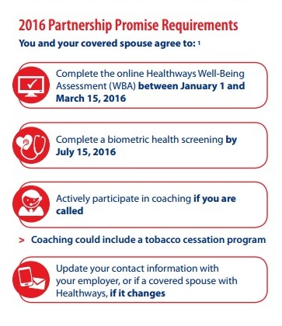

DENTAL

Eligible employees continue to have a choice of two dental plans. Although the carriers have changed, the plan designs remain the same. Note, the prepaid dental option will have a rate increase in 2016.

Members currently enrolled in the Assurant Prepaid dental option who do not make changes will automatically be enrolled in Cigna for 2016. Members will automatically be transferred to their current dentist if that provider is in Cigna’s DHMO network. Members with a dentist not in-network, or those signing up with Cigna Dental for the first time, will automatically be assigned to the dentist closest to their home address. This automatic process is being utilized to facilitate the printing of an ID card for each covered member, which can only occur if a dentist is assigned. Members may select a new dentist at any time.

Likewise, members currently enrolled in the Delta PPO dental option who do not make changes will automatically be enrolled in MetLife dental for 2016.

Eligible members who wish to enroll or make plan changes must make an election in Edison Self Service during the open enrollment period.

Option 1

Cigna Prepaid Plan (Cigna DHMO) – employees selecting this option will be required to choose a participating provider from the specified list and notify Cigna of their choice. The network for this plan is Cigna Dental Care (DHMO).

Option 2

MetLife DPPO Dental – employees selecting this option will have access to all providers; however, maximum benefits are received when utilizing an in-network provider. The network for this plan is MetLife PDP.

Employee Dental Premiums (monthly)
Coverage Level | Cigna DHMO | MetLife DPPO
Employee Only | $12.61 | $21.51
Employee + Child(ren) | $26.18 | $49.46
Employee + Spouse | $22.35 | $40.69
Employee + Spouse + Child(ren) | $30.73 | $79.62

OPTIONAL VISION INSURANCE
Eligibility Criteria: Benefits eligible employees may elect to participate in the State vision plan.
The State vision plan is voluntary coverage provided through EyeMed. This means that participating employees pay the full premium. EyeMed premiums are deducted on a pre-tax basis.

Eligible employees have a choice between the following two vision plan options:

Basic Plan - Employee Monthly Vision Premiums
Coverage Level | Monthly Premium
Employee Only | $3.35
Employee + Child(ren) | $6.69
Employee + Spouse | $6.35
Employee + Spouse + Child(ren) | $9.83

Expanded Plan - Employee Monthly Vision Premiums
Coverage Level | Monthly Premium
Employee Only | $5.86
Employee + Child(ren) | $11.72
Employee + Spouse | $11.14
Employee + Spouse + Child(ren) | $17.23

OPTIONAL TERM LIFE INSURANCE
If you are currently enrolled and are eligible for a guaranteed issue increase, information will be mailed to you.
If you and/or your dependent spouse are not presently enrolled, you will be required to present evidence of insurability through a health questionnaire. Enroll through the Minnesota Life website at lifebenefits.com/stateoftn.
Premiums will increase in 2016 and included below:

Voluntary Term Life Monthly Premium Rates - 2016
Age | Employee and Spouse Rate per $1,000
Under 25 | $0.047
25-29 | $0.047
30-34 | $0.051
35-39 | $0.062
40-44 | $0.095
45-49 | $0.161
50-54 | $0.271
55-59 | $0.422
60-64 | $0.658
65-69 | $1.092
70-74 | $1.523
75-79 | $2.340
80 and up | $4.229

LONG-TERM CARE
Eligible employees, their eligible dependents (spouse and children ages 18-25), retirees, parents, and parents-in-law may elect to enroll in long-term care coverage. Long-term care is subject to medical underwriting and is available through MedAmerica. Please visit ltc-tn.com for enrollment information.

GET AQUAINTED with TBR sponsored benefits

1. Open Enrollment – TBR SYSTEM – September 15 through October 15
a. Flexible Spending Account (Full and Limited) - Payflex
- Voluntary Vision Plan - VSP

- Annual Transfer Period – TBR SYSTEM – September 15 through October 15
  - Long Term Disability – Prudential
  - Voluntary Cancer, Critical Illness, Accident, etc. - AFLAC

- Charitable Giving Campaign – TBR SYSTEM – September 15 through October 15

- Sick Bank Open Enrollment – TBR SYSTEM OFFICE – September 15 through October 15
tbr – OPEN ENROLLMENT OPPORTUNITIES

FLEXIBLE SPENDING ACCOUNT (FSA) – Open Enrollment
Eligibility Criteria: Regular employees working 80% or 30 hours per week are eligible to participate in the Flexible Spending Account (FSA) plan. Employees who elect a Consumer CDHP may only enroll in a Limited Purpose FSA and should calculate the annual election amount using only forecasted dental and vision expenses. Employees participating in the Partnership and Standard PPO plans may enroll in the full FSA program, which can be used for qualified medical, dental, and vision expenses.
The minimum annual Healthcare FSA election is $120.00 and the maximum annual is $2,550.00.

If you want a medical and/or dependent day care reimbursement account in 2016, you must sign up during the TBR Open Enrollment Period (9/15-10/15) – even if you are already participating. This open enrollment is effective January 1, 2016.

A Flexible Spending Account permits employees to set aside a specified number of pre-tax dollars up to an annual maximum for use for purposes permitted by the Internal Revenue Service (IRS). In general, these are certain types of childcare expenses and certain types of qualified health-related expenses. Before making an election based on receiving a certain procedure (i.e. Lasik eye surgery), please ensure 1) that you are a candidate for the procedure and 2) it is a qualified expense under the IRS guidelines in which the FSA operates. TBR's FSA is administered by Payflex, a division of Aetna.

VOLUNTARY VISION PLAN – Open Enrollment
Eligibility Criteria: Employees working 80% or 30 hours per week are eligible to participate in the TBR vision plan. Coverage is effective January 1, 2016. Vision insurance premiums will not increase in 2016.
The TBR vision plan is voluntary coverage provided through VSP. This means that participating employees pay the full premium. VSP premiums are deducted on a post-tax basis. Eligible employees may enroll online at www.tbrbenefits.com.

Eligible employees have a choice between the following two vision plan options:

Bronze Plan - Employee Monthly Vision Premiums *
Coverage Level | Monthly Premium
Employee Only | $4.42
Employee + Child(ren) | $9.48
Employee + Spouse | $8.84
Employee + Family | $15.15

Gold Plan - Employee Monthly Vision Premiums*
Coverage Level | Monthly Premium
Employee Only | $9.59
Employee + Child(ren) | $20.54
Employee + Spouse | $19.21
Employee + Family | $32.84

*Monthly premiums include a 6% administrative fee.

tbr – ANNUAL TRANSFER PERIOD OPPORTUNITIES

LONG TERM DISABILITY – Annual Transfer Period
Long-term Disability (LTD) provides income protection in the event an employee becomes disabled due to a covered sickness or accidental bodily injury. During the annual transfer period, the following allowed changes can occur (all terms and conditions of the policy will apply):

- Employees that are currently participating may increase their level of coverage at annual transfer by completing an enrollment form and evidence of insurability form (EOI)). All increases must be approved by Prudential before the increase in benefit is effective.

- Employees that are currently participating may decrease their level of coverage during the annual transfer period without completing EOI.

- Employees who failed to enroll when first eligible may apply for coverage during the annual transfer period by submitting EOI. Coverage will be effective once approved by Prudential.
Employees may voluntarily terminate coverage at this time. Employees who terminate coverage will be considered a late entrant if they decide to reenter the plan during a subsequent annual transfer period.
LTD insurance premiums will not increase in 2016.

LTD Premiums - Non-Exempt:
Option 1 Rates – 180 Days/50%: |  | Option 2 Rates – 120 Days/60%: |  | Option 3 Rates – 90 Days/60%:
<30 | $0.091 | <30 | $0.140 | $0.091 | $0.168
30-34 | $0.091 | 30-34 | $0.140 | $0.091 | $0.168
35-39 | $0.119 | 35-39 | $0.203 | $0.119 | $0.238
40-44 | $0.168 | 40-44 | $0.287 | $0.168 | $0.336
45-49 | $0.287 | 45-49 | $0.469 | $0.287 | $0.567
50-54 | $0.413 | 50-54 | $0.679 | $0.413 | $0.805
55-59 | $0.546 | 55-59 | $0.903 | $0.546 | $1.064
60-64 | $0.588 | 60-64 | $0.980 | $0.588 | $1.155
65+ | $0.588 | 65+ | $0.980 | $0.588 | $1.155
To determine your cost:
Annual earnings $_________ ÷ 1,200 = $________ X rate from table $________ = monthly cost $___________

*Maximum $48,000 for Option 1; $80,000 for Option 2; and $140,000 for Option 3.

LTD Premiums - Exempt:
Option 1 Rates – 180 Days/50%: | Option 2 Rates – 120 Days/60%: | Option 3 Rates – 90 Days/60%:
$0.105 | $0.148 | $0.195
To determine your cost:
Annual earnings $_________ ÷ 1,200 = $________ X rate from table $________ = monthly cost $___________

*Maximum $48,000 for Option 1; $80,000 for Option 2; and $140,000 for Option 3.

Voluntary Worksite Benefits – Open Enrollment
Eligibility Criteria: Voluntary supplemental benefits are available upon hire and during the annual Benefits Open Enrollment. Products are offered through AFLAC with convenient payroll deductions. During open enrollment, employees may elect coverage via www.aflacatwork.com/tbr.

Hospital Indemnity – Level 1
(Group Supplemental Hospital Indemnity –#CAI8576hsa)

Monthly Premiums* Benefits
Ages 18 - 64  $16.89 | The Supplemental Hospital Indemnity plan provides benefits for inpatient as a result of covered accidents and sickness. Please refer to the Group Supplemental Hospital Indemnity Brochure for specific benefits, definitions, and exclusions.

*Monthly premiums include a 6% administrative fee.
Accident
(Group Accident 24-Hour Coverage - #CAI7776TN)

Monthly Premiums* Description
Ages 18 – 69  $17.09 | Group Accident insurance pays a benefit for the treatment of injuries suffered as the result of a covered accident. Benefits are paid regardless of any other health insurance benefits the insured may receive. Please refer to the Group Accident Brochure for specific benefits, definitions, and exclusions.

*Monthly premiums include a 6% administrative fee.

Critical Illness
(Group Critical Illness - #CAI2876TN)

Monthly Premiums* Description
Non- Tobacco Rates:  First $5,000 of coverage  Ages 18 to 29 $ 5.07  Ages 30 to 39 $ 6.71  Ages 40 to 49 $10.47  Ages 50 to 59 $16.46  Ages 60 to 69 $24.68  Tobacco Rates:  First $5,000 of coverage  Ages 18 to 29 $ 6.39  Ages 30 to 39 $ 9.31  Ages 40 to 49 $18.53  Ages 50 to 59 $29.76  Ages 60 to 69 $45.88 | Guaranteed Issue:  · Newly Eligible Employees (hired after July 31, 2015): $20,000 for employees and $10,000 for spouse  · Current Insureds: additional buy up benefit of $10,000 for employees and $5,000 for spouse  · Late Enrollees (employees/spouses who were previously eligible and elected not to enroll): $5,000 for employees and $5,000 for spouse  · Maximum benefit of $50,000 for employees and $25,000 for spouse  Group Critical Illness provides a lump-sum benefit upon the diagnosis of not only one covered illness, but for each covered illness. Please refer to the Group Critical Illness Brochure for specific benefits, definitions, and exclusions.

*Monthly premiums include a 6% administrative fee.

Personal Sickness Indemnity
(Individual Hospital Confinement Sickness Indemnity –#A45075B1TN)

Monthly Premiums* Description
Ages 18 to 39 $21.41  Ages 40 to 49 $23.96  Ages 50 to 59 $29.79  Ages 60 to 64 $41.45 | Individual Hospital Confinement Sickness Indemnity provides cash benefits directly, which can be used for treatment costs or everyday bills. Please refer to the Individual Hospital Confinement Sickness Indemnity Brochure for specific benefits, definitions, and exclusions.

*Monthly premiums include a 6% administrative fee.

Cancer Indemnity
(Individual Maximum Difference Essentials –#A761ESTN)

Monthly Premiums* Description
Ages 18 to 35 $11.99  Ages 36 to 45 $14.74  Ages 46 to 55 $19.43  Ages 56 to 70 $24.94 | Individual Maximum Difference Essentials provides cash benefits directly, which can be used for treatment costs or everyday bills. Please refer to the Individual Maximum Difference Essentials Brochure for specific benefits, definitions, and exclusions.

*Monthly premiums include a 6% administrative fee.

tbr – ADDITIONAL BENEFITS

HOLIDAYS

The following dates will be observed as TBR System Office holidays in 2016:

- Friday, January 1, 2016 - New Year's Day
- Monday, January 18, 2016 - Martin Luther King Day
- Monday, May 30, 2016 - Memorial Day
- Monday, July 4, 2016 - Independence Day
- Monday, September 5, 2016 - Labor Day
- Thursday, November 24, 2016 and Friday, November 25, 2016 - Thanksgiving Day & One Administrative Closing Day
- Friday, December 23, 2016 - Friday, December 30, 2016 Christmas Day and Five Administrative Closing Days

LONGEVITY PAY

Eligibility Criteria: Upon completion of 36 months of service, all regular full-time employees are eligible for longevity payments. In addition, all regular part-time employees who are scheduled to work 1600 or more hours in a fiscal year and have 36 months of service are also eligible for longevity payments.

Eligible employees shall receive longevity pay at an established rate for each year of creditable service up to the maximum provided by law. The rate per year of service is currently $100 and is established annually by the Legislature.

EDUCATIONAL ASSISTANCE

Educational Assistance Programs provide benefits to employees at TBR institutions, Tennessee Colleges of Applied Technology, and employees of the System Office to further their formal education. Programs are also available for dependents of TBR employees. The following programs are subject to eligibility based on service requirements and funding:

Educational Assistance for TBR Employees
- Faculty or Administrative/Professional Staff Grant-in-Aid Program
- Faculty or Administrative/Professional Staff Tuition or Maintenance Fee Reimbursement Program
- Employee Audit/Non-credit Program
- Clerical and Support Staff Tuition or Maintenance Fee Reimbursement Program
- Fee Waiver for TBR System Employees Program (P 191)

Educational Assistance for Spouse and Dependents of TBR Employees
- Fee Discount for Spouse and/or Dependent Children Program

EMPLOYEE ASSISTANCE PROGRAM (EAP)

TBR participates in the State’s Employee Assistance Program (EAP), which provides counseling services for employees and eligible dependents who may be experiencing personal or workplace problems.

Magellan Health Services is the current EAP provider. All services are strictly confidential and can be accessed by calling 1.855.HERE.4.TN (1.855.437.3486), seven days a week, 24 hours a day.

Below are just a few of the many issues EAP can help with:
• | Stress | • | Adjusting to change
• | Depression and anxiety | • | Child and elder care
• | Family or parenting issues | • | Workplace concerns
• | Alcohol or drug dependencies | • | Grief and loss
• | Marital or relationship issues | • | Work/life balance
• | Financial issues | • | Legal Consultation

Magellan also offers confidential and anonymous access to a wide variety of information and resources on their web site at www.Here4TN.com.

tbr – EMPLOYEE CHARITABLE GIVING

CHARITABLE GIVING CAMPAIGN

TBR approves the entire list of nonprofit agencies listed in the TBRECC brochure as eligible to receive donations from TBR employees.

Employees can choose several organizations to receive a payroll deduction gift. Donations can be made to the federations (Community Health Charities, Community Shares, or any county United Way), to member/partner charities affiliated with one of the federations, and to the independent charitable organizations listed in the brochure.

tbr – SiCK LEAVE BANK

SICK LEAVE BANK OPEN ENROLLMENT

System Office employees wishing to join the System Office Sick Leave Bank may sign-up during the annual enrollment period of September 15 – October 15. Please refer to P-061 for further details and eligibility.

RETIREMENT PROGRAM OPPORTUNITIES

VOLUNTARY DEFERRED COMPENSATION
In addition to the employer provided retirement program, the TBR offers several deferred compensation plans to allow employees to save for retirement on a tax-deferred basis. Contributions to these plans are made through regular payroll deductions. Salary set aside through these plans cannot be withdrawn before separation from service except under a few limited circumstances. Participants in these plans are permitted to direct their contributions among a variety of investment options. TBR matches up to $50.00 per month of employee contributions to the 401(k) plan.
There are four optional retirement savings plans operated by the State of Tennessee Treasury Department and/or TBR:
- 457 • Roth After-tax
- 401(k) • 403(b)

Benefits are an important part of your total compensation. Be sure to take time to review your choices and select the best benefits for you and your family.

This guide contains a summary of benefit features. It does not describe all benefits and benefit limitations under the plans. For a complete description of benefits you must refer to the plan documents.

