Financial Wellness

EverFi Training Programs: Transit and @Work

Address financial wellness in higher education

Make well-informed financial decisions

Be financially stable

Completing Transit

Modules:
Set A Set B
- Back to School 2.0 4. Best Life Ever
- Best Weekend Ever 5. Salary Split
- Balancing Act 6. Payback Time

Logging in:
Go to: everfi.com/login
- If you created an EverFi Higher Ed account Fall 2016: Just login, Transit is already on your dashboard
- If you have an EverFi Higher Ed account from before Fall 2016: Go to your account, and in the upper right corner under “add a course” enter your school’s registration code
  - If you have never used EverFi Higher Ed: Click “Register” and then enter your school’s registration code

Pre/Post Survey:
Before starting Transit, you will be given a survey to gauge your financial knowledge prior to the training.
Then, after 4-6 weeks you will be emailed a reminder to complete the post-training survey.

By completing these surveys, you are contributing to the financial literacy of those who come after you.

Action Plans:
Use the action plan to help you practice the skills and use the tools you learn from Transit.
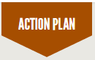

Completing @Work

Modules:
- Financing Higher Education
- Overdraft
- Credit Scores & Reports
- Checking Accounts
- Credit Cards

Logging in:
- Go to: atwork.everfi.net/tbrtcatfinancial
- Click the Register link below the Login Option
- Enter account information
- Click the box below to accept “Terms of Use”, then click “Create Account”

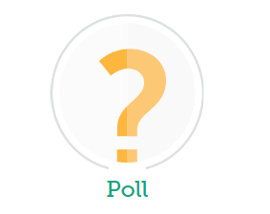
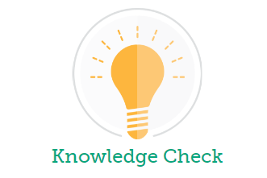

Knowledge Checks and Polls:
- Knowledge check tests knowledge gained from slides
- Polls track responses from students

For Technical Support: atworksupport@everfi.com or by phone at 855.303.0423

Notes:

