Office of Academic Affairs

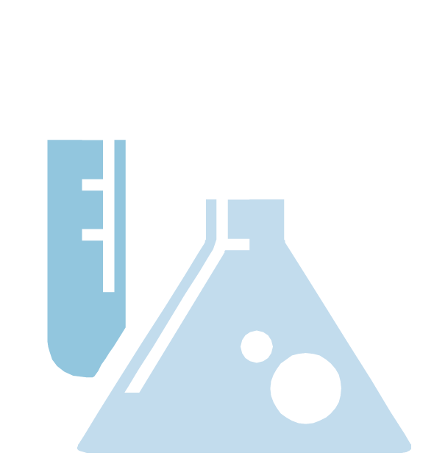

How to Use
the High Impact Practice Taxonomy
for Institutional Self-Study

Instructions and Sample Assessments

How a campus uses the HIP Taxonomy Framework for the institutional self-assessment is a CAMPUS decision. Below are two suggested methods for gathering feedback using the taxonomy framework.

Option #1

- Distribute the taxonomy to a broad representation of faculty, staff, and administrators directly involved in the implementation and oversight of the specific high impact practice.

- Have each member go through each “program element” highlight the descriptions listed under the milestone column that best describes the current status of the practice on your campus.

- Each participant should score each program element. If the campus meets all of the standards within a particular milestone, then the overall program element can be judged as being at that level. For example, in order to say a campus is a “milestone 2” campus, it must meet all requirements in the milestone 2 column for the particular element. If the practice meets all of the standards in milestone 2 and a few at milestone 3, the campus is still only at milestone 2.

- Each participant’s summary scoring can be collected and compared to get a sense of what the majority of reviewers feel is the current status of each high impact practice.

- Once input is gathered from all team members and overall scores are obtained, the campus assessment of the high impact practice is complete.

Option #1: Example

Campus Y has sent out the taxonomy to a representative group, and a faculty member who leads a study abroad trip is asked to do the self-assessment from her perspective. Below is how she scored the self-study for study abroad for the first two elements (if it is shaded blue, she feels the campus meets that standard):

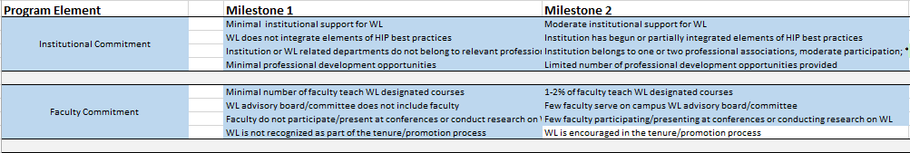
For the program element “institutional commitment” the faculty member feels study abroad is at milestone 2, since she has highlighted all the criteria within that milestone for that program element.
For the program element, “faculty commitment,” the faculty member has highlighted all criteria from the milestone 1 column and 4 from the milestone 2 column. Therefore, she has assessed “faculty commitment” to be at milestone 1. (Remember that all criterion from a milestone must be met before the program element can be identified with that level.)

After the faculty member shades in each program element, she looks at the overall taxonomy assessment. There are 5 elements at Milestone 2 and 6 elements at Milestone 1. She concludes that, as a whole, study abroad on her campus is at Milestone 1.
When the faculty member’s assessment is compared with what others submitted, the group has 8 assessors who feel study abroad is at Milestone 2 and 5 assessors who feel study abroad is at Milestone 1. Thus, the team determines that study abroad, as a practice on that campus, is at Milestone 2.
Option #2

1. Convene a representative group of faculty, staff, and administrators directly involved in the implementation and oversight of the specific high impact practice.

2. Collectively decide where the practice is in its development for your campus. Note that unless all program elements for a particular milestone are achieved, the campus cannot report that they are at that milestone.

3. For each element of the taxonomy, shade in the criteria listed in each milestone level that best describes your campus practices.

4. Look at the overall scoring for each program element to determine the milestone level for the high impact practice.

Option #2: Example

Campus Z invited a 13-member team to meet in a conference room to assess service-learning using the taxonomy. Through their group discussions, they coded the 10 program elements in the following manner. Again, all standards which the group feels the campus meets, are shaded in blue:
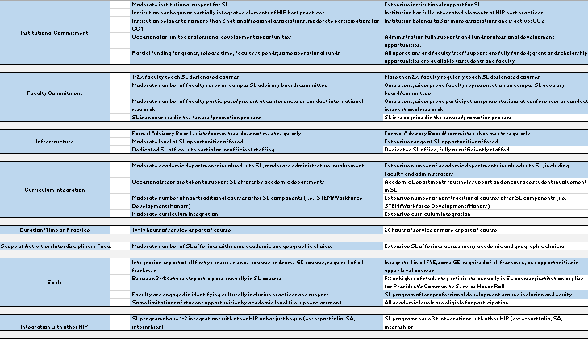
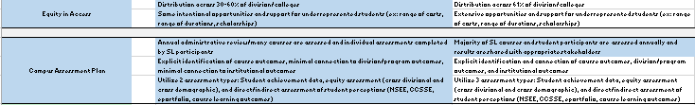

As a result of the group’s assessment, the campus determines that service-learning on the campus is at Milestone 2 since they meet all of the standards in that milestone, but still have work to grow the practice in a few of the program elements to meet the standards in Milestone 3.

A Note about Operational Definitions:
The assessor will see the use of words like “adequate,” “moderate,” or “sufficient” on the taxonomy framework and may wonder, “What measure do I use to ascertain whether we meet this standard?” In an effort to recognize the variance in our campus operations, exact measures are largely avoided on the taxonomy. Instead, campuses are asked to identify how these terms are defined for the institution and then consistently apply that definition when doing the self-study for the high impact practice. In some cases, the campus may decide that that individual assessor’s determination of how to define the terms is sufficient since the final results will be a compilation of perspectives from various vantage points.

Once the Self-Study is Complete:

- Presidents are asked to share the results of their institutional self-assessment for the high impact practices of study abroad, service-learning, and work-based learning at their 2015 Institutional Briefings with the TBR System Office.

- Campuses should use the self-assessment to determine the milestone level they would like the practice to exist within for that particular campus.

- For campuses that aspire to move the practice to the next milestone, the framework gives guidance on the minimum standards to strive for as a campus.

- For campuses that aspire to move to the next milestone for a particular program element, the framework gives guidance on where to intentionally focus its work within the high impact practice.

- In spring 2016, campuses should begin coding HIP-related, credit-bearing experiences in Banner. The taxonomies’ minimum definitions can be used to identify these courses. Ultimately, faculty will need to accurately identify courses that meet the minimum definitions and criteria.

CAUTION: The System Office intends to send out guidance in spring 2016 on how to code these experiences in Banner based on the identified taxonomy criteria. Do not change your current practices until you receive this guidance.

