TBR Connector
Applicant Tracking System
Hiring Manager Guide

Table of Contents
1 Getting Started 4
1.1 Welcome 4
1.2 Roles and Responsibilities 4
1.2.1 Roles 4
1.3 Logging On 4
1.3.1 Password Requirements: 4
2 Major Processes 5
2.1 Job Requisition (Post Position) 5
2.1.1 Assumptions 5
2.2 Applicant Selection / Workflow 5
2.2.1 Assumptions 6
3 Examples 7
3.1 Request Requisition 7
3.1.1 Requisition Review 10
3.2 Approve Requisition 11
3.2.1 Pre-Screening (HR) 12
3.3 Review Requisition 12
3.4 Review Applicant Qualifications 14
3.4.1 Review Applicants 14
3.4.2 Job Details 15
3.4.2.1 Applicant Flags 15
3.4.3 Applicant Profile Overview 17
3.4.3.1 Applicant Summary Tab 18
3.4.3.2 Applicant Statuses Tab 18
3.4.3.3 Application Tab 19
3.4.3.4 Application Profile - Other Comments 19
3.4.3.5 Comments Tab 19
3.4.3.6 Documents Tab 20
3.4.3.7 History Tab 21
3.4.3.8 Email Tab 21
3.4.4 Change Status (Group or Individual) 22
3.4.4.1 Group (Job Details Page) 22
3.4.4.2 Individual (Applicant Summary Tab) 24
3.4.5 Status - In Review 25
3.4.6 Status - In EEO Review 25
3.4.7 Status – Interview (Schedule) 26
3.4.8 Status – Recommend for Hire 28
3.4.9 Status – Offer Letter 28
3.5 Conduct Interview 30
3.6 Manage Offer 33
3.6.1 Offer Approval Workflow 33
3.6.2 Submit Offer to Candidate 34
3.6.1 Offer Response 35

Getting Started

Welcome
Welcome to the TBR Connector! We are excited to have this opportunity to introduce our new solution, provided by Cornerstone OnDemand (CSOD).
This integrated solution helps manage the hiring workflow from requisition to request to hire, including:
- Requisition request, approval and tracking
- Internal posting of open positions
- External posting of open positions to the TBR website
- Accept applications via the internet
- Store electronic applications and related information
- Group applications by job / requisition to assist in review
- Applicant selection workflow
- Monitoring and notifications
- Offer letter creation, approval and tracking
The TBR Connector is hosted on the cloud, allowing access 24 hours a day, 7 days a week – except for scheduled maintenance.

Roles and Responsibilities

Roles
All employees involved in the hiring process will have one or more roles.
- Hiring Managers - Access to all functionality outlined in this training manual. Note that only the person who submits the requisition request will see the status of the requisition as it moves through the review and approval process.
- Reviewers – Access to applicant information for review.
- Approvers - Approve requisition requests. Receive email notification when an offer has been issued to one or more applicants
- Interviewers - Assigned dynamically by the system. Anyone identified as an Interviewer is given access to review applicant information and record his/her assessment of each applicant.

Logging On
TBR employees will access the TBR Connector via a link from the TBR website. Your User ID will be your email; however, your password is managed separately. If you forget your password, the system will generate an email so you can reset it.

Password Requirements:
- Upper and lower case letters, alpha and numeric, at least 1 special character
- 8 – 20 characters in length
- Cannot use the same character 3 or more times consecutively

Major Processes

Job Requisition (Post Position)
Job requisitions are initiated within the department.

Assumptions
Key assumptions regarding the job requisition process:
- A Requisition Template must exist in order to make a requisition request. This means that the position must be defined, including the job ad, grade, salary range, qualification criteria, job application, approval hierarchy, interviewers, hiring workflow (i.e. statuses) and offer letter template. Any changes to the template associated with a position must be addressed with Human Resources and incorporated within the template prior to initiating the request.
- Requisition requests can only be submitted for budgeted positions. Human Resources will review each requisition request to ensure that the position has been budgeted before continuing with the approval process.
- All requisition requests are reviewed by Human Resources. Following review, requisition requests must be approved by the hiring manager, Vice Chancellor, and the Chancellor.

Applicant Selection / Workflow
Search committee chairs will assess applicant qualifications through a series of steps or ‘statuses’, which are pre-defined in the Requisition Template. Interview guides, a series of pre-defined questions used for departmental interviews, can optionally be defined in advance and associated with a requisition for consistent interviewing.
For most positions, the steps (statuses) are as follows:
In Review – The applicant’s qualifications are under review by the hiring department to determine whether to schedule follow up – such as an interview.
EEO Review – EEO review of applicants.
Interview – The hiring department has selected the applicant for an interview (which can be by phone, in person, or via video conference).
Recommend for Hire – The applicant has or will receive an offer letter.

Human Resources staff manage remaining steps in the general Applicant Workflow, which are as follows:
Background Check – Human Resources staff will conduct a background check, as needed for the position. The hiring manager will receive an email notification of whether the applicant progresses or is disqualified.
Closed – Once the position has been filled, Human Resources staff will close the requisition. The system will generate an email notification to all applicants who were not selected.
Hired – Human Resources staff will change the status of external applicants to ‘Employee’, and update internal applicants to their new position.

Assumptions
Key assumptions regarding the applicant selection process:
- Applicant ‘reviewer’ is a pre-defined role associated with each requisition. The hiring manager and search committee will be assigned as reviewers.
- The hiring manager and the search committee will have access to applicant qualifications.
- The search committee chair will consolidate interview feedback and record interview results.
- Offer letters will be generated from a standard, pre-defined template associated with the requisition.
- All offers must be reviewed and approved by the hiring manager, Vice Chancellor of the department, Human Resources, Vice Chancellor for Business and Finance and the Chancellor.

Examples

Request Requisition
Only the person who makes the requisition request can access the request to review / monitor progress.

- Select Recruit > Requisition Requests
- You will see a list of previously submitted requests. Select ‘Create New Request’

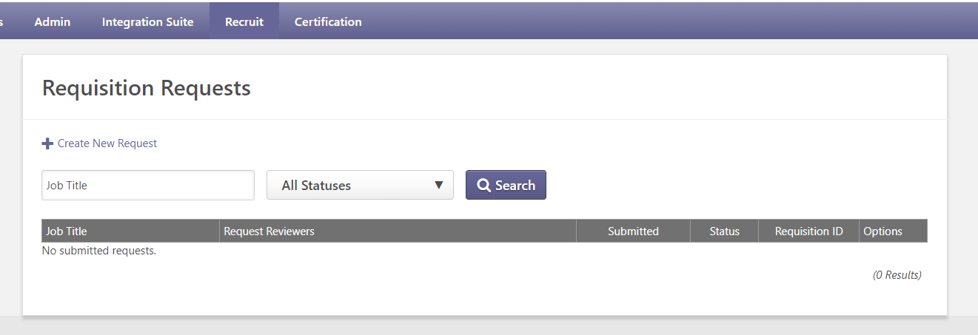

- Click the Position arrow to display a list of defined positions (partial screen shown below)
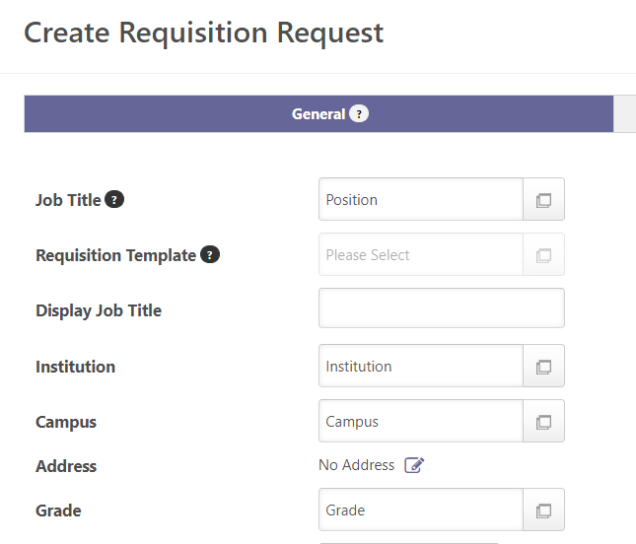

- Enter Search criteria, or page through available positions to find the position you want to fill.
- To expand the section, click on the +
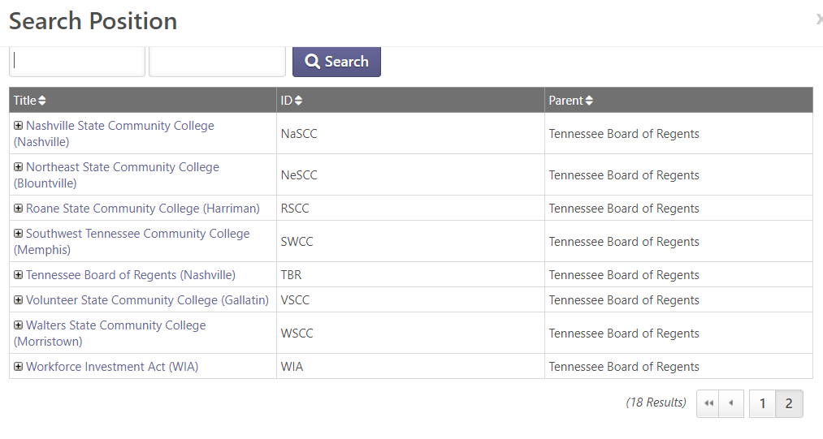
c. Select the position. You will return to the Requisition Request page, where the requisition will be updated with information from the requisition template (partial screen shown below).

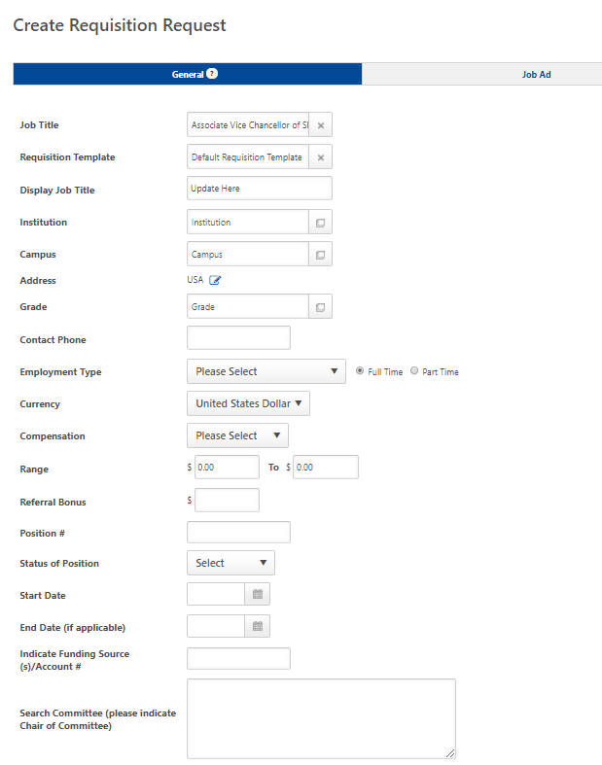

- Enter the remaining information and press Submit Request
- Use the Job Posting fields and related dates to specify when the position will be available for application and when the posting will expire
Use Comments for any additional explanation.

Requisition Review
Once you have submitted the requisition request, the Human Resources Department will review the request.
- If approved, the requisition will be submitted into the Department’s approval workflow.

- If rejected, you will need to copy the requisition, make required corrections, and resubmit.
Requisitions require approval by the Vice Chancellor of the Department, Diversity and Equity, Business and Finance, and Human Resources.

To Copy a requisition request, click the ‘Copy’ icon.
Click the bubble icon to see why the request was declined.

Approve Requisition
You will receive an email notification when you have a requisition(s) to approve.
- Logon and select Recruit > Recruiting Approvals
- Select the requisition to review the position information. Press the check mark to approve, or strikeout to reject.
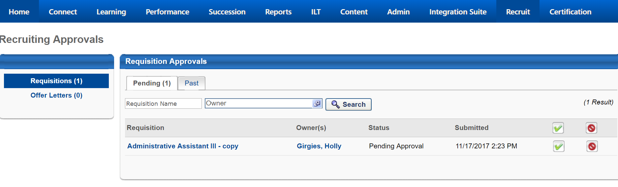
- After making a selection, add a comment to explain your decision (if desired).
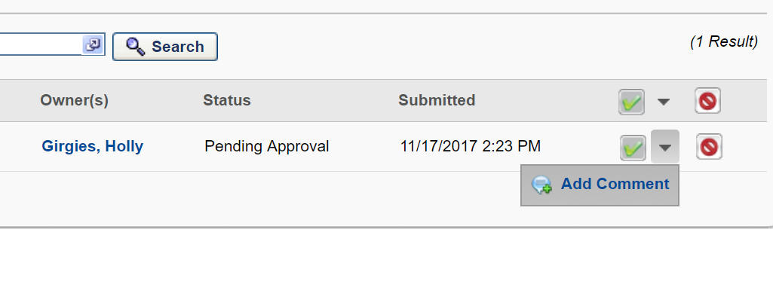

- Press the Submit button. Your approval will generate an email to the next approver.
When all approvals have been received, the position will automatically post as specified in the requisition.
External postings will be available from the TBR website, Employment Opportunities link.

Pre-Screening (HR)
Human Resources staff will review and prescreen incoming applications based on minimum qualifications defined for the position. The search committee chair will be notified via email as soon as each applicant has passed the prescreening phase.
Applications that have passed prescreening will display in the counts on the Applicant Review and Job Detail pages.

Review Requisition
You can access the requisition to see the status at any time (provided you initiated the requisition request).
- Select Recruit > Requisition Requests
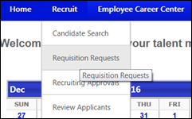

- All pending and approved requisitions you have submitted will display. Click the Requisition ID to see any applications that passed pre-screening.
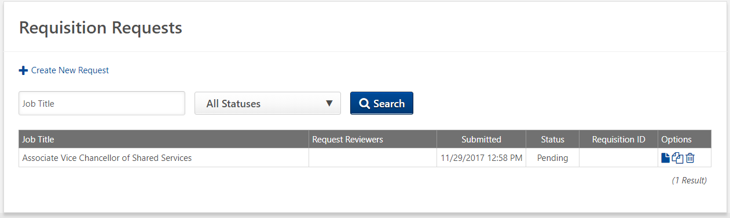

- Select the number under ‘Applicants’ to review applicant information (you can also access applicants from the Welcome page by selecting Recruit > Review Applicants).
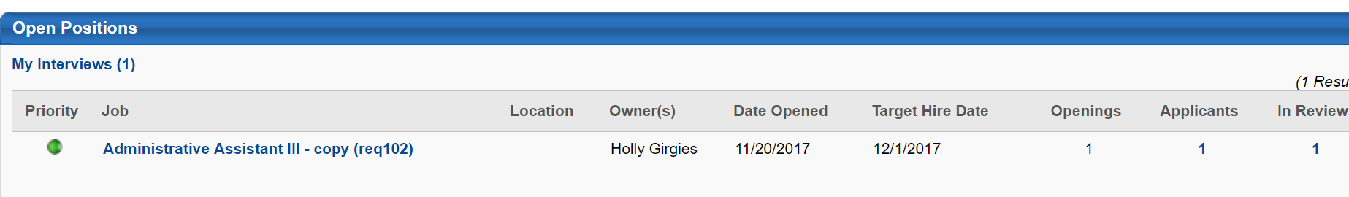

Review Applicant Qualifications
When an applicant submits an application, the system creates an Applicant Profile. The Profile stores the application, attached documents, forms, email and additional information manually entered during the selection process (such as assessments and scores). The Profile also shows the status of the application, which indicates progression through the Applicant Selection process.
You can access the Applicant Profile via several menus and links in the Recruiting application.

Review Applicants
- From the Welcome page, select Recruit > Review Applicants. (Note: You can also access Applicants from the requisition. See section 3.3 Review Requisition).

You will see a summary of Open Positions for which you are a Reviewer (defined in the Requisition Template).
- This position has received 1 application; all are currently in the initial review stage. Select the number in the Applicants column (i.e. ‘1’).

Job Details
- The top section of the Job Details page shows the applicant selection process and how many applicants are in each stage (‘status’)
- Each applicant is listed in the bottom section of the page, along with information regarding their application including: current status, date of last change, submission date, flags and match criteria.
You can customize fields displayed for each applicant (in each row) using the Edit icon
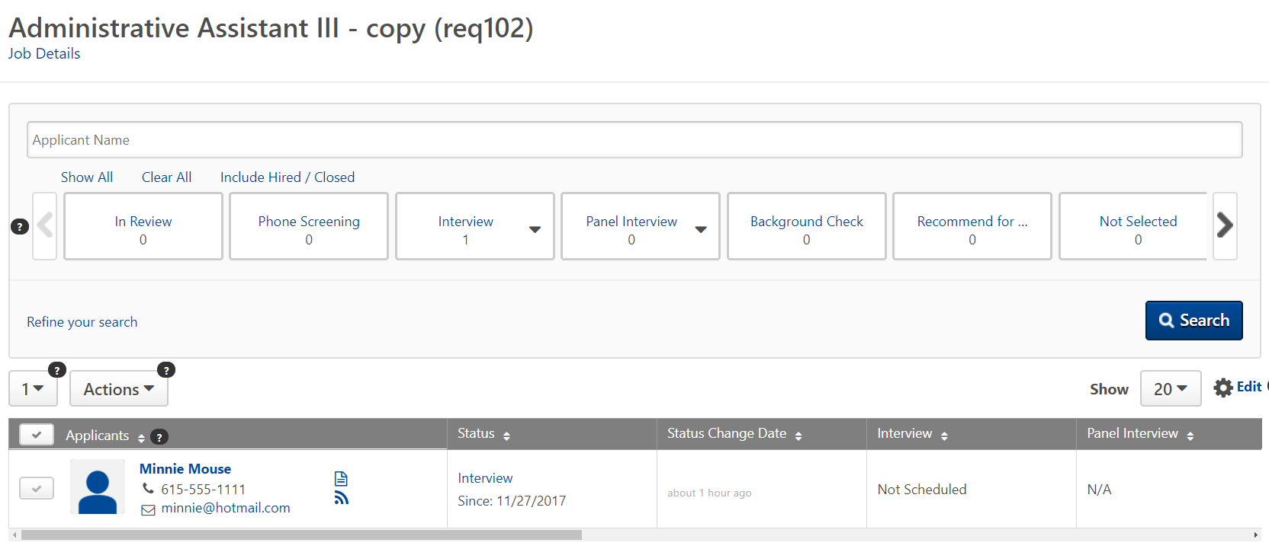

Applicant Flags
Applicant flags indicate information regarding the employee. Hover over the flag for a definition, or click for details.
The following flags have been defined:
- Not Eligible for Rehire – set by Human Resources during prescreening
- Merged Duplicate Applicants - identifies target profile under which duplicate applicants are merged. The system applies this flag automatically
- Potential Duplicate Applicant - Applicants with this flag are identified as potential duplicate applicants. The system applies this flag automatically based on matching data in the user record
Flags are visual cues and can be used as search criteria to find applicants. However, setting a flag does not change the status of an employee or cause an offer to generate – these actions are manual.

Applicant Profile Overview
From the Job Details page, select an applicant name to review the Applicant Profile
- The left section of the page displays all positions for which the applicant has applied. The ‘Snapshot’ hyperlink provides access to the submitted application, documents and custom fields (defined below).
- The middle section shows applicant information for the current position.
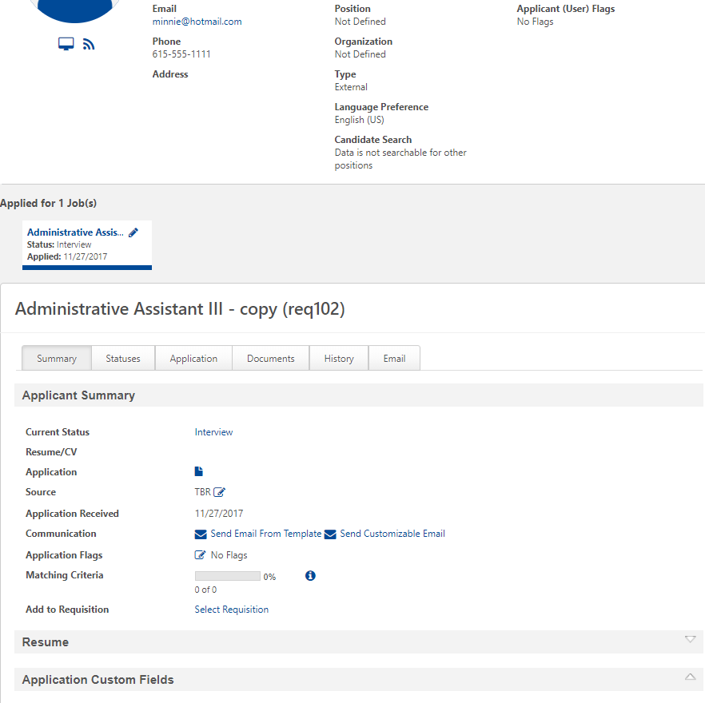

Applicant Summary Tab
The Applicant Summary tab (see above) shows the applicant’s status. From the Applicant Summary tab, you can review the application and resume, review position information, change the applicant’s status, initiate a template-based or free-form (‘customizable’) email, review flags, review matching criteria, and view/edit application custom fields (based on permissions).

Applicant Statuses Tab
Applicant Statuses show the applicant’s progression through the selection process. Initially, the applicant is in ‘In Review’ status, pending review of his/her qualifications.
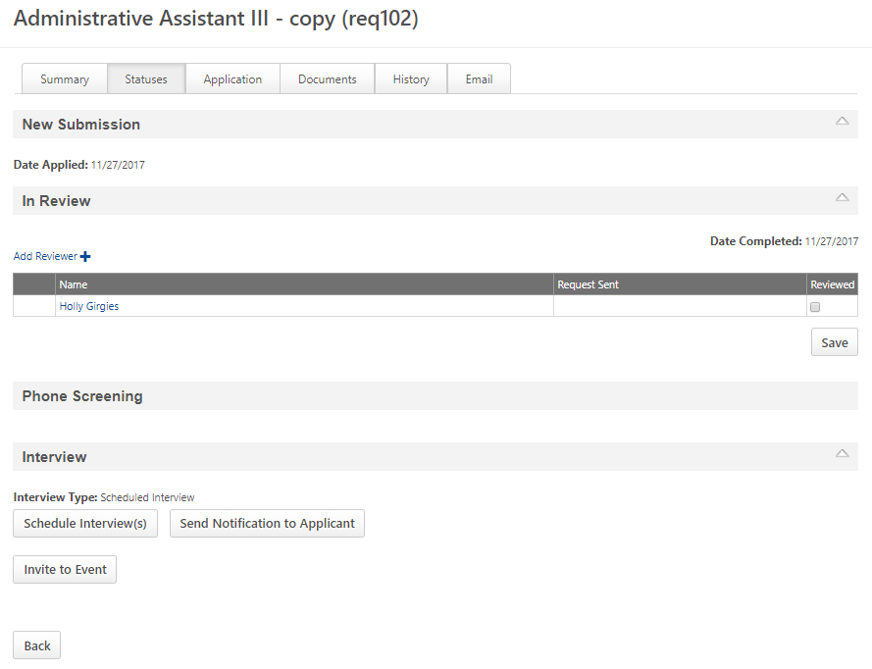

Application Tab
The Application tab displays the submitted application, by section. Select the down arrow to display detailed information for each section.
EEO information collected on the application is confidential and can only be viewed by authorized personnel.

Application Profile - Other Comments
Offer Letter Approval Comments are available under the Applicant Profile > Statuses tab (offer status)
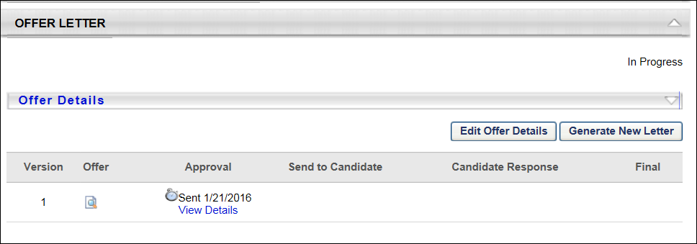

Comments Tab
The Comments tab provides a summary view of all Comments added to the applicant for the position. It displays the following types of Comments:
- Comments entered directly on the Comments tab
- Interviewer recommendations
- Comments entered by Offer Letter approvers

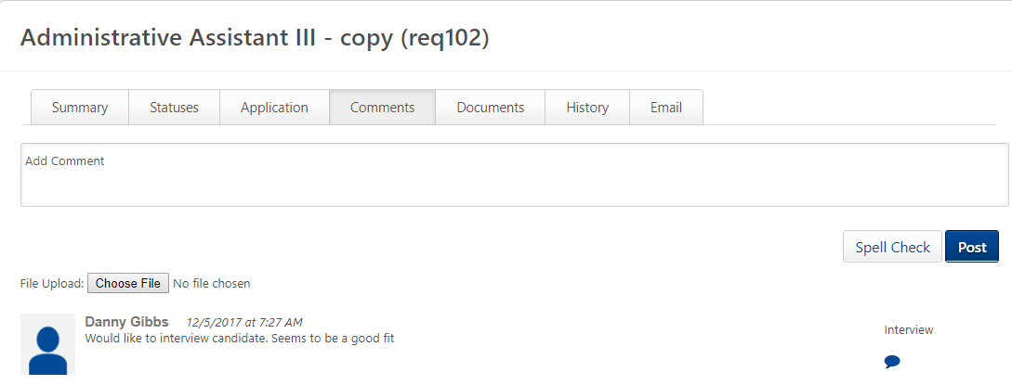

Documents Tab
The Documents tab shows all documents associated with the applicant for the specified position.

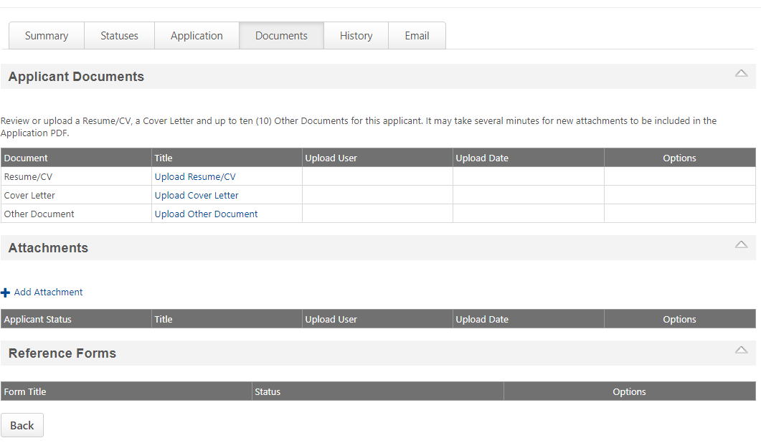

History Tab
The History tab shows all actions, emails and documents associated with the applicant for the selected position. 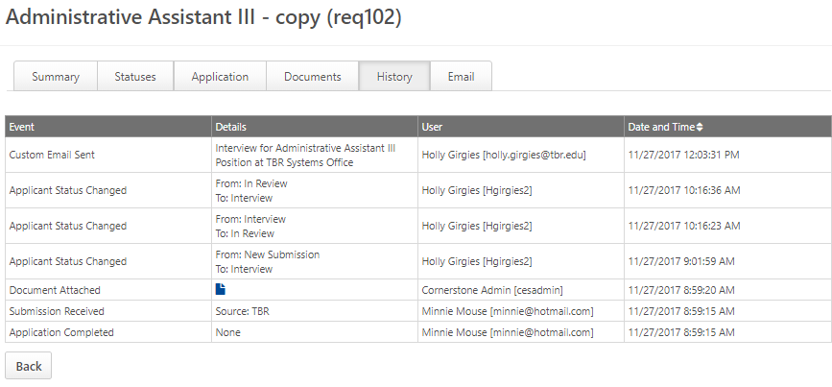

Email Tab
The Email tab displays all customizable (free form) and template (predefined) email.

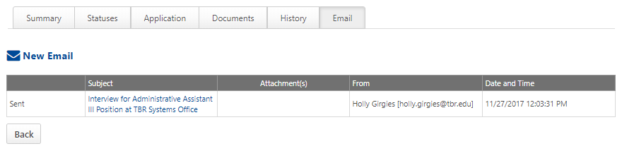

Change Status (Group or Individual)
In order to move applicants through the selection process, you must change their status.

Group (Job Details Page)
Group changes are made on the Job Details page.
- Click the check mark to select one or more applicants
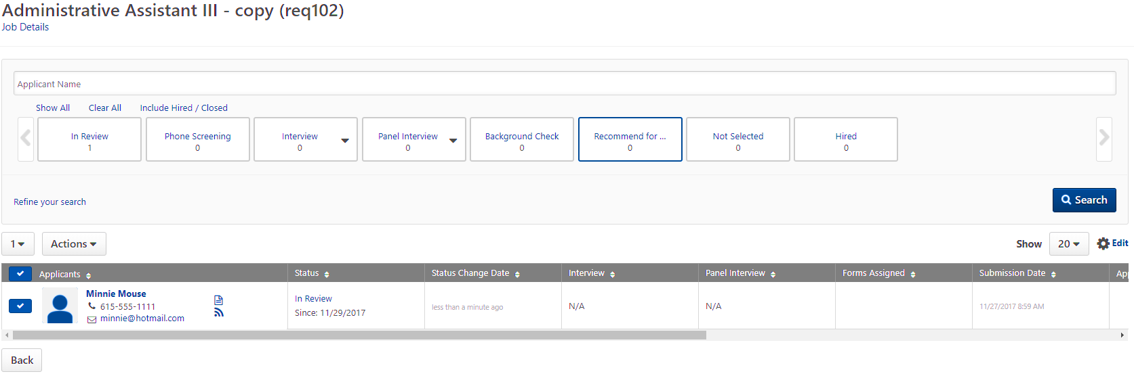

- Select ‘Change Status’ from the Actions dropdown.
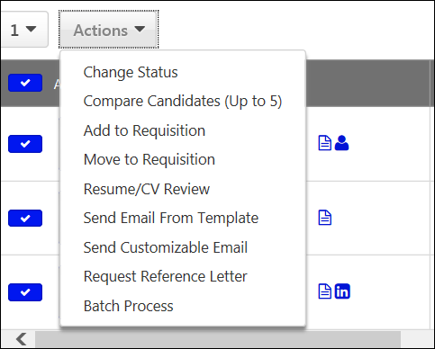
- Select the new status for each applicant from the New Status dropdown. To progress all selected applicants to the same status, select the new status from the ‘Change Status To’ dropdown.
- Press Submit to continue.
Mandatory statuses are marked with an asterisk. These statuses cannot be skipped.
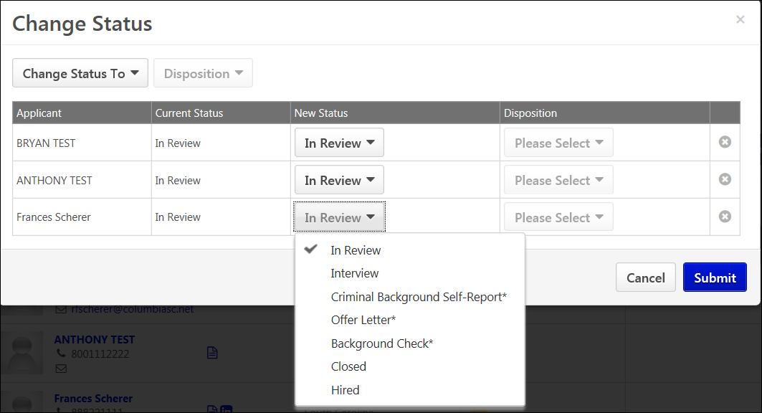

Individual (Applicant Summary Tab)
- Select the Current Status hyperlink (‘In Review’)
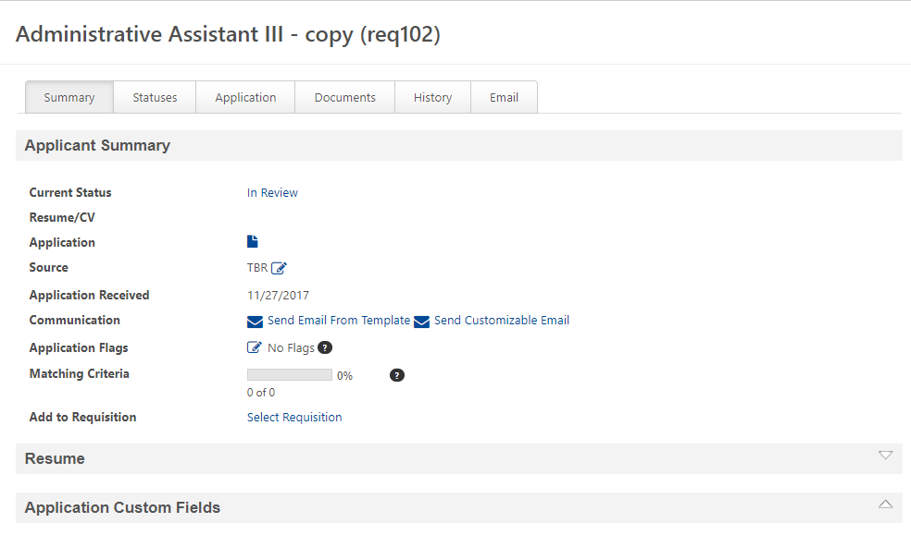

- Select the new status, then press Submit
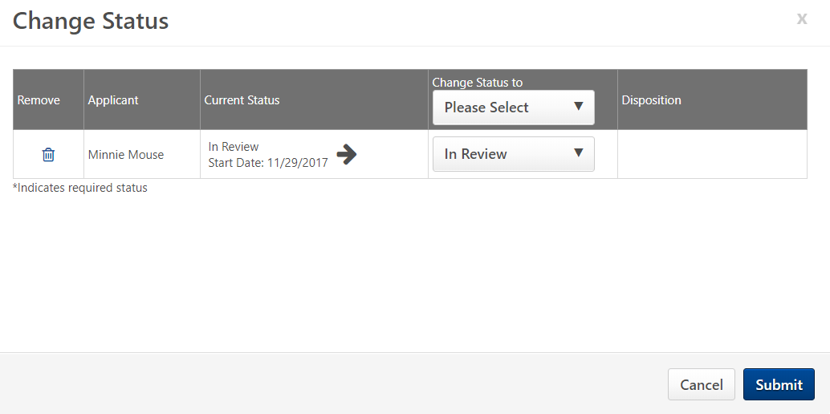

Status - In Review
Initially, the applicant is in ‘In Review’ status, pending review of his/her qualifications.
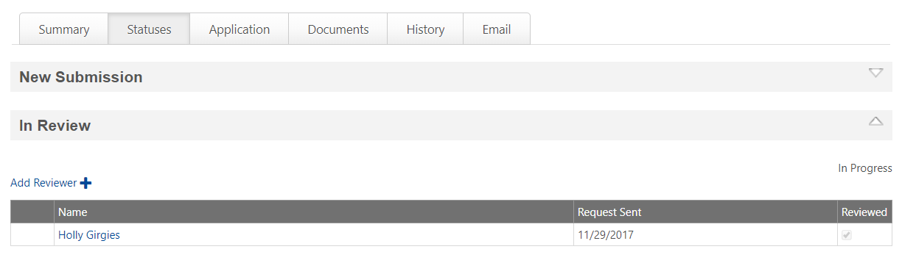
- Once you have reviewed applicant information (Summary page), mark your review as complete and press the ‘Save’ button.

Check to make sure all necessary reviews have been completed before changing the status from ‘In Review’.

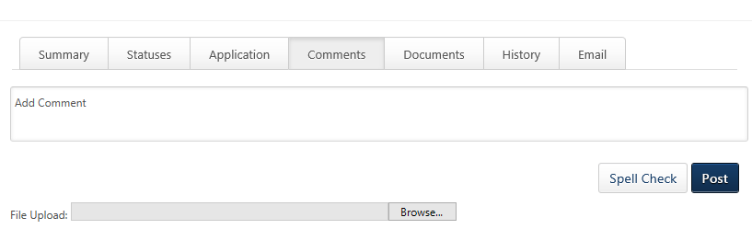
- Enter comments for the applicants chosen for interviews on the applicant profile page. This enables recruiters to view and create comments in one location in order to share feedback and notes about the applicant.

Status - In EEO Review
The search committee chair will place the applicants they wish to interview into EEO Review status. Equity and Human Resources will approve the interview list or recommend changes. HR will then move the applicants to Interview Status.

Status – Interview (Schedule)
When an applicant is in Interview status, you can schedule interviews and notify participants. Setting up interviews in the system allows you to record interviewer feedback and attach the feedback to the applicant profile.
This section defines how to schedule interviews. Refer to section 3.5 Conduct Interview to see how to record interview results.

- Go to the Applicant Profile > Statuses tab
- Select the arrow for the Interview stage
- Select the ‘Schedule Interviews’ button
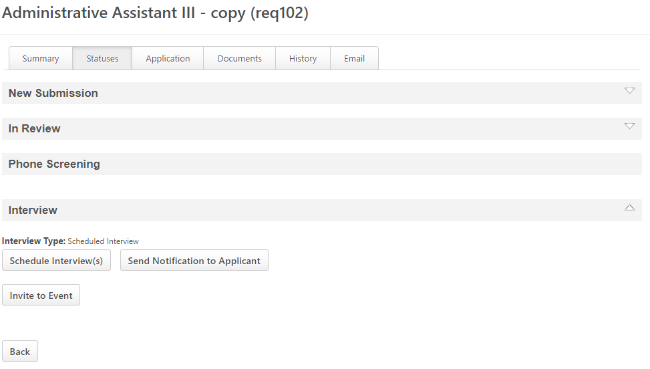

- Select the ‘Click to add Interviewers’ hyperlink to add Interviewers
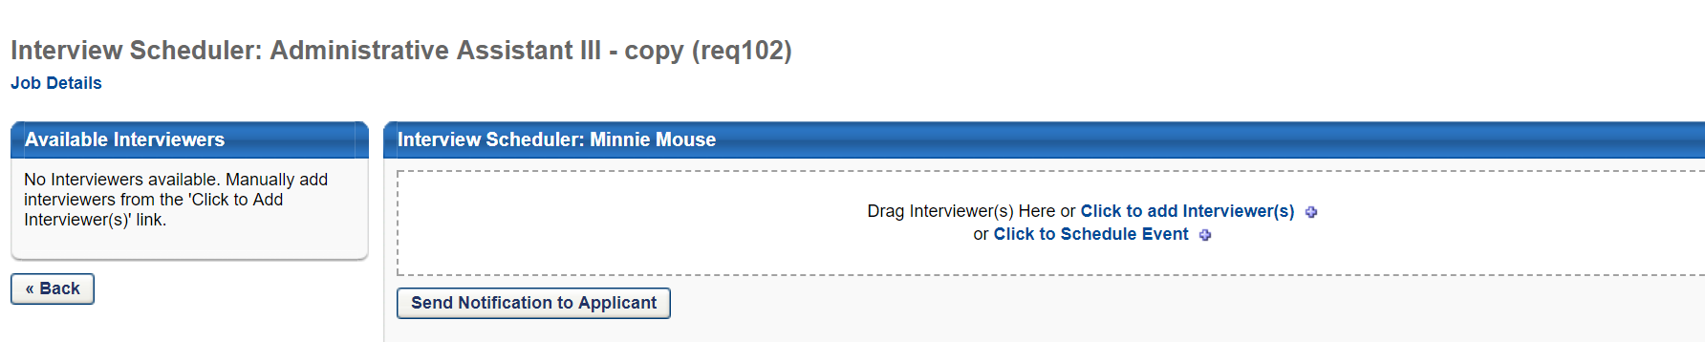
- Schedule the interview and notify participants
Interview Locations will not be maintained in TBR Connector. If you use the system to notify the applicant, be sure to specify the interview location in Comments.

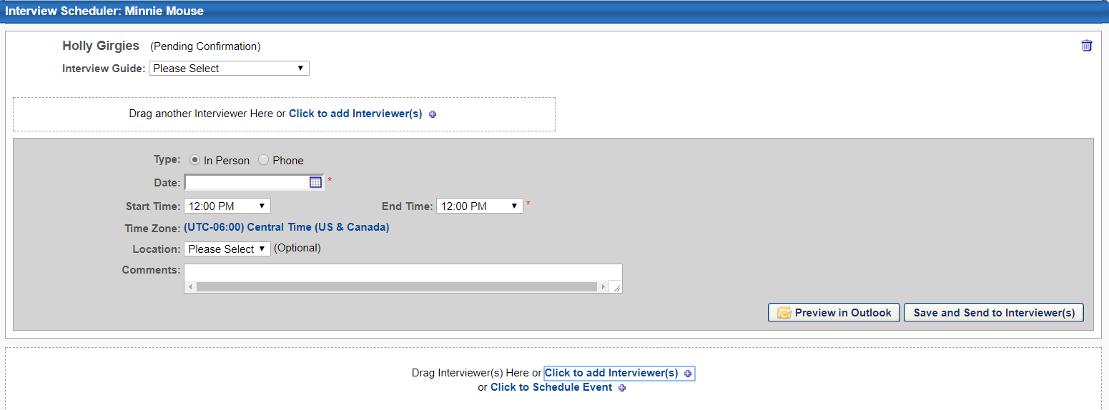

Notify Interviewer – Press the ‘Save and Send to Interviewer(s)’ button
Comments can be used to provide additional information to the interviewers. This information cannot be seen by the Applicant.

Notify Applicant – Press the ‘Send Notification to Applicant’ button.
Comments for the Applicant are entered on the Applicant Scheduling window
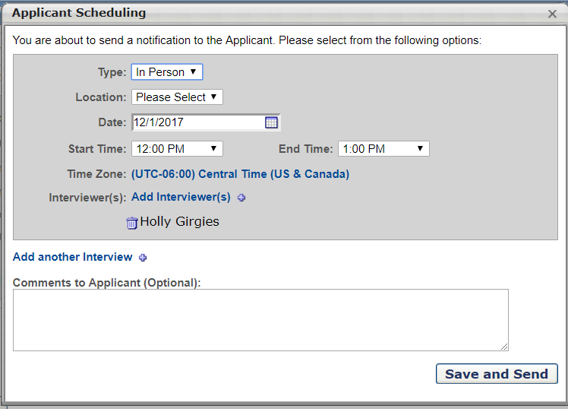
- The interview will display in the applicant’s profile. S/he will also receive an email notification.

Status – Recommend for Hire
If the hiring department decides to move an applicant forward following the Interview stage, the hiring manager will move the applicant to Recommend for Hire – this action generates an email to Human Resources.
Human Resources staff will submit an on-line form to be completed by the applicant, and review the applicant’s responses. Any issues that disqualify the applicant for the position will be documented in a secure field available to designated HR staff only.
If the applicant has not been disqualified, Human Resources will move the applicant to ‘Offer Letter’ status. The hiring manager will receive an email notification.

Status – Offer Letter
Once an applicant has been placed in Offer Letter status, decision-makers within the department will determine whether to issue an offer.
To create the offer letter, go to the Applicant Profile > Statuses tab.
- Most fields will be pre-populated. Complete remaining fields: Salary, Hiring Manager Job Title, Job Grade, and start date. Use Notes to record any information relevant to approvers.
- Press the ‘Save and Create New Letter’ button
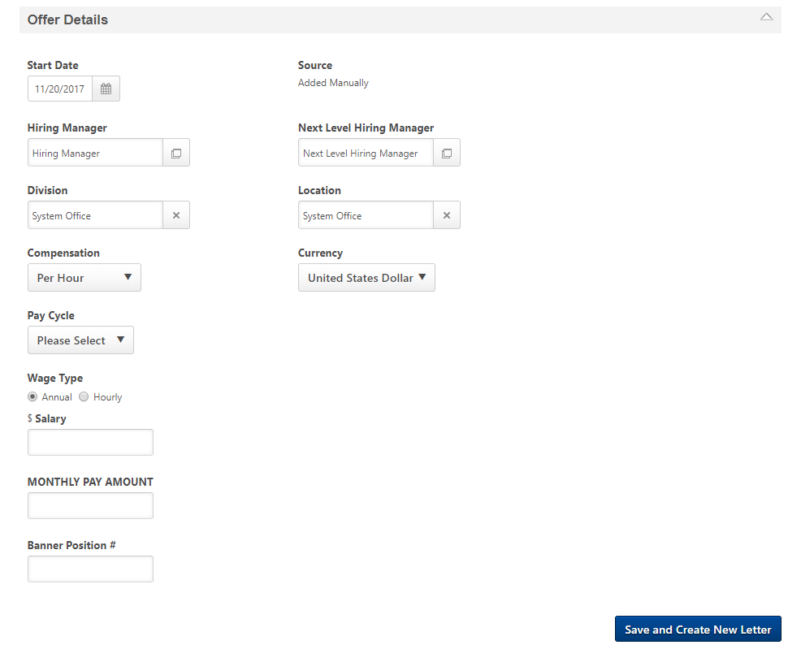
- Review the letter, then press the ‘Save and Create Offer’ button
You can review the letter by using the scroll bar or pressing the PDF icon for a preview.

- Press the ‘Submit for Approval button to start the approval process.
If you need to modify the letter before submitting, press Edit Offer Details and Generate New Letter.
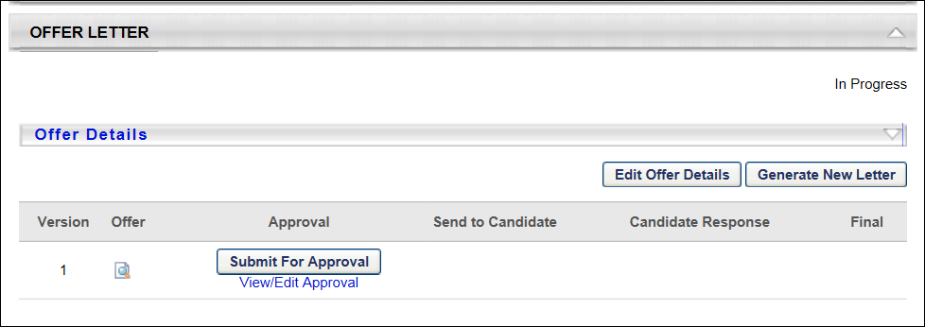

The hiring manager will be the first approver for his/her offers. S/he must approve the offer to continue the approval workflow. Refer to section 3.6 Manage Offer.

Conduct Interview
After completing the interview, interviewers will provide their recommendations to the search committee chair. The search committee chair will record interview results.
- Select Recruit > Interview Manager

- Select the applicant
- Select Record Recommendation from the Options dropdown
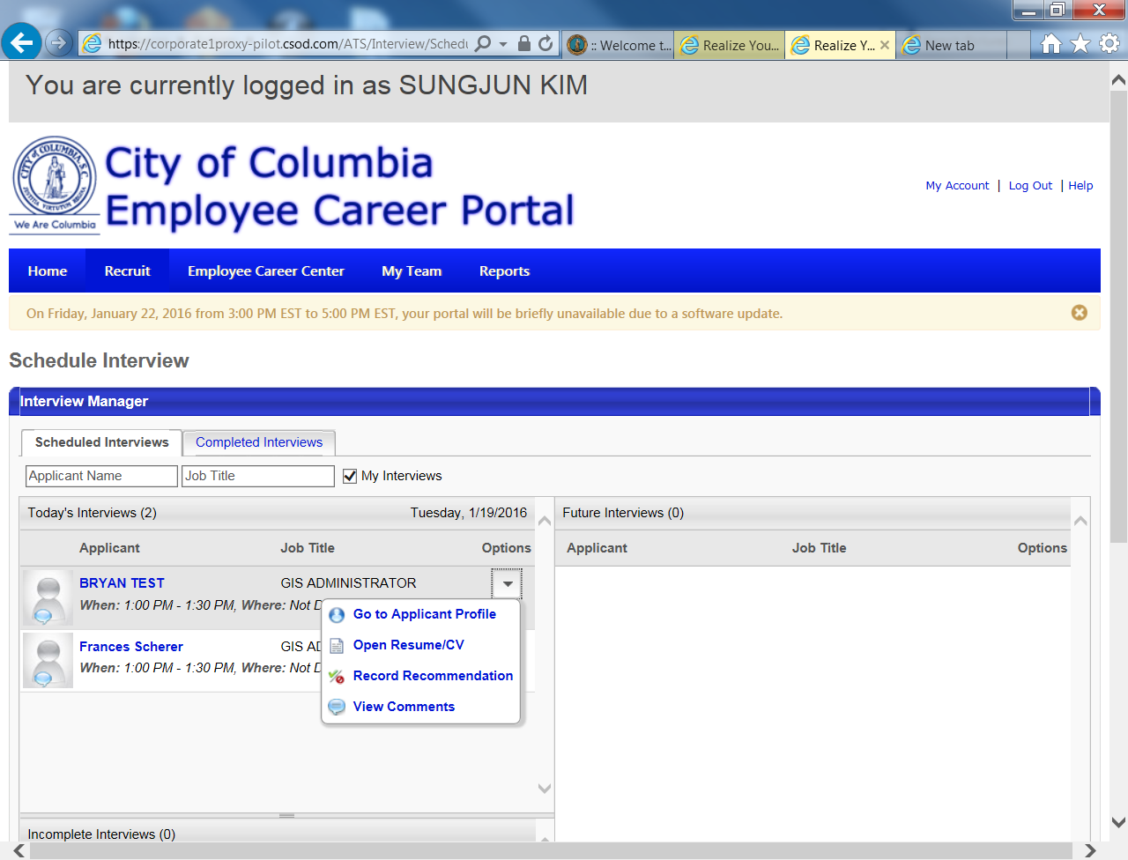

- Record the recommendation. Select the check mark to move forward, or the strikeout sign to remove the applicant from further consideration.
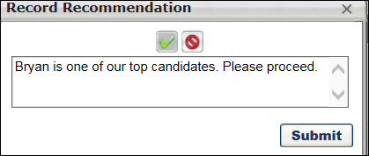
- Press Submit to store this information on the Applicant Profile.

Manage Offer

Offer Approval Workflow
The hiring manager, Vice Chancellor of the department, Human Resources, Vice Chancellor of Business and Finance, and Chancellor must approve each offer. Each person in the approval workflow will receive an email notification of offers pending approval.
- Go to Recruit > Recruiting Approvals
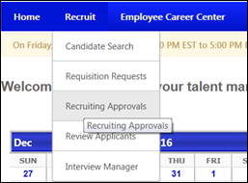

Recruiting Approvals displays pending and past requisitions and offer letters. From here, you can review the candidate’s qualifications, requisition and offer letter by pressing the hyperlinks and icons.
- Press the Offer icon to review the letter.
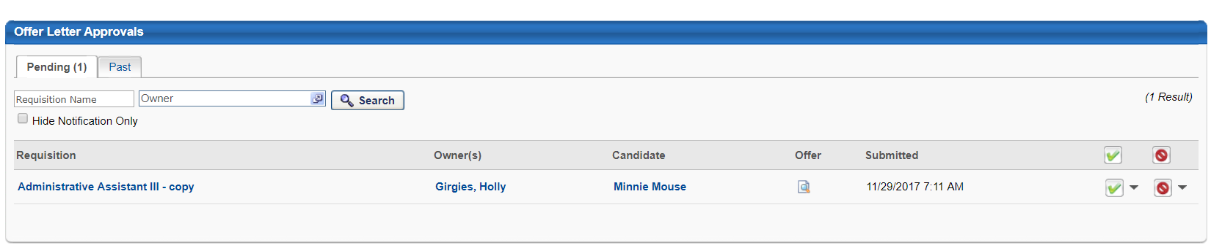

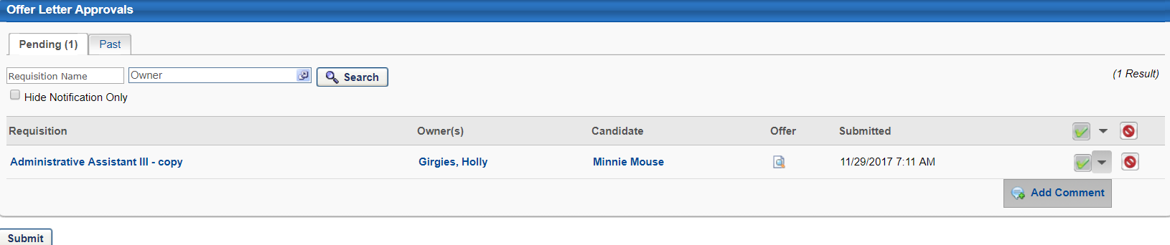
- Select the checkmark to record your approval, or strikeout to reject. Once you have approved the offer, you can add comments.

- Press Submit to record your approval.
- You can see the progress of the offer letter approvals from the Recruiting Approvals screen. Any approvals or denials will show along with approver’s comments.

Submit Offer to Candidate
Once the offer has been approved, return to the Applicant Profile > Statuses tab to send the offer to the candidate. The hiring manager will complete this step.
- Press the ‘Send Offer’ button
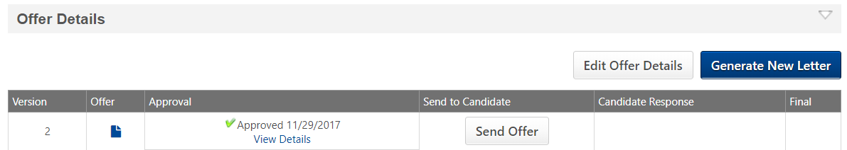
- Select the Email method, add instructions or attachments, and press Send Email.
- Select the Candidate Profile method, add instructions or attachments, and press Send Email.

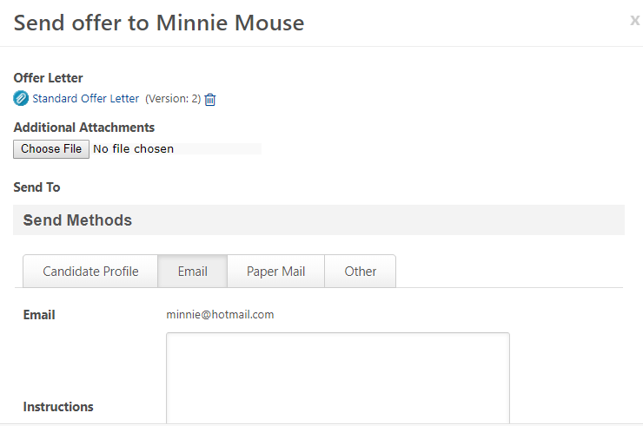

Offer Response
When the Applicant responds to your offer you will receive an email notification. The Applicant’s response displays on the Applicant Profile > Statuses tab.
