How to Approve an Offer Letter
- Go to Recruit > Recruiting Approvals
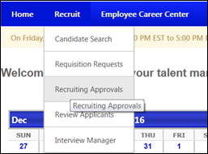
Recruiting Approvals displays pending and past requisitions and offer letters. From here, you can review the candidate’s qualifications, requisition and offer letter by pressing the hyperlinks and icons.
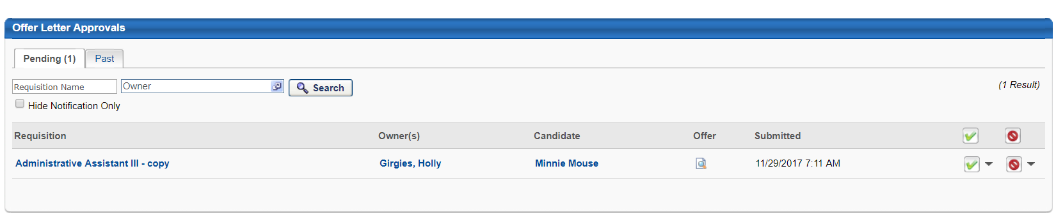
- Press the Offer icon to review the letter.

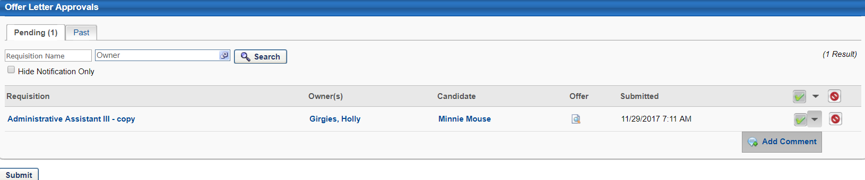
- Select the checkmark to record your approval, or strikeout to reject. Once you have approved the offer, you can add comments.

- Press Submit to record your approval.
- You can see the progress of the offer letter approvals from the Recruiting Approvals screen. Any approvals or denials will show along with approver’s comments.

