Manage Hired Applicants

The Manage Hired Applicants page is used to bridge the gap between making a hiring decision in the Applicant Tracking System and creating a functional employee user record. Users with the appropriate permission can create new employee user records and make the necessary changes to internal candidate user records in order for the candidates to display correctly as employees. The hire date is the date the applicant’s status changed to hired. This is not their start date.

1. To access the Manage Hired Applicants page, go to ADMIN > TOOLS > RECRUIT > HIRED APPLICANTS.
2. Find the applicant that you would like to create a user record for.
3. Click on either update or create beside their name.
4. If edits are needed to the user record, click on Edit under User Settings. Edits could include changing their supervisor, updating personal information, etc.
5. Click on Complete when finished making any updates.

The Manage Hired Applicants table displays internal and external candidates that are in a status of Hired. Candidates do not appear on this page unless they are in a Hired status. The visibility of candidates is dependent upon the user's permission constraints.

The table is sorted by most to least recent hire date. All columns are sortable, except Employee Info, User Settings, and Complete.

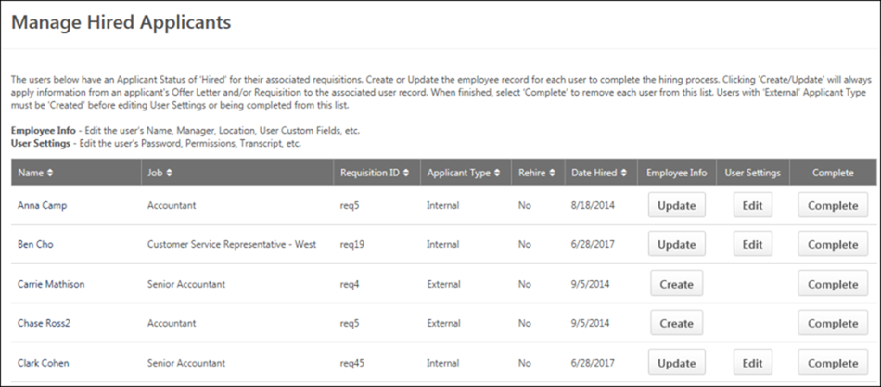

| **COLUMN** | **DESCRIPTION** |
| --- | --- |
| Name | This column displays the candidate's name. |
| Job | This column displays the display name of the job requisition for which the candidate was hired. |
| Requisition ID | This column displays the unique ID of the job requisition for which the candidate was hired. |
| Applicant Type | This column displays whether the candidate is an internal or external applicant. |
| Rehired | This column indicates whether or not the hired applicant is a former employee who has been rehired. The column displays "Yes" if the applicant is a former employee, and it displays "No" if the applicant is not a former employee. |
| Date Hired | This column displays the date on which the candidate's status changed to Hired. |
| Employee Info | The following options are available in this column:   * Create - The **CREATE** button displays for external candidates and enables you to create a user record for the candidate. Click the button to open the Add/Edit User page. * Update - The **UPDATE** button displays for internal candidates and enables you to update the candidate's user record. Click the button to open the Add/Edit User page. |
| User Settings | The following options are available in this column:   * Edit - The **EDIT** button displays for all candidates and enables you to open the Users page from which you can edit a candidate's user record. However, the button is only selectable once an active user record exists for the candidate. Click the button to open the Users page. The candidate appears in the search results. * Restricted - If you do not have permission to edit user settings for the user, then "Restricted" displays for the candidate in the User Settings column. |
| Complete | The **COMPLETE** button displays for all candidates but is only selectable once an active user record exists for the candidate. Clicking the button removes the candidate from the Manage Hired Applicants page. Future updates to the user record must be made from the User's page, which can only be accessed if you have permission to edit user records. |