How to Move New Submissions to Applicants or Does Not Meet Minimums
- Go to Recruit > Manage Requisition
- Find the job requisition you are wanting to prescreen applicants for
- Click on the number under New Submissions to bring up all candidates
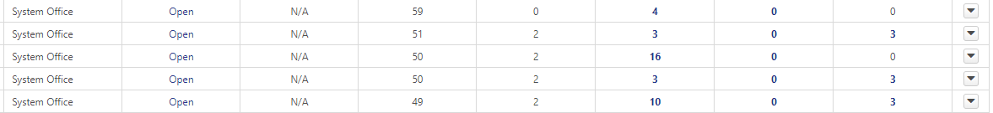

- If the candidate is qualified and you wish to move them to the applicant pool, click on the green check mark
- Click the Next button at the bottom of the screen
- Change their Status to In Review
- Click Process
- If the candidate is not qualified and you do not wish to move them forward in the process, click on the red Stop Sign
- Click Next
- Change their Disposition to the appropiate dispostion. *Note: This is also how you can change their dispostion to voluntary withdraw if the candidate withdraws.
- Click Process

