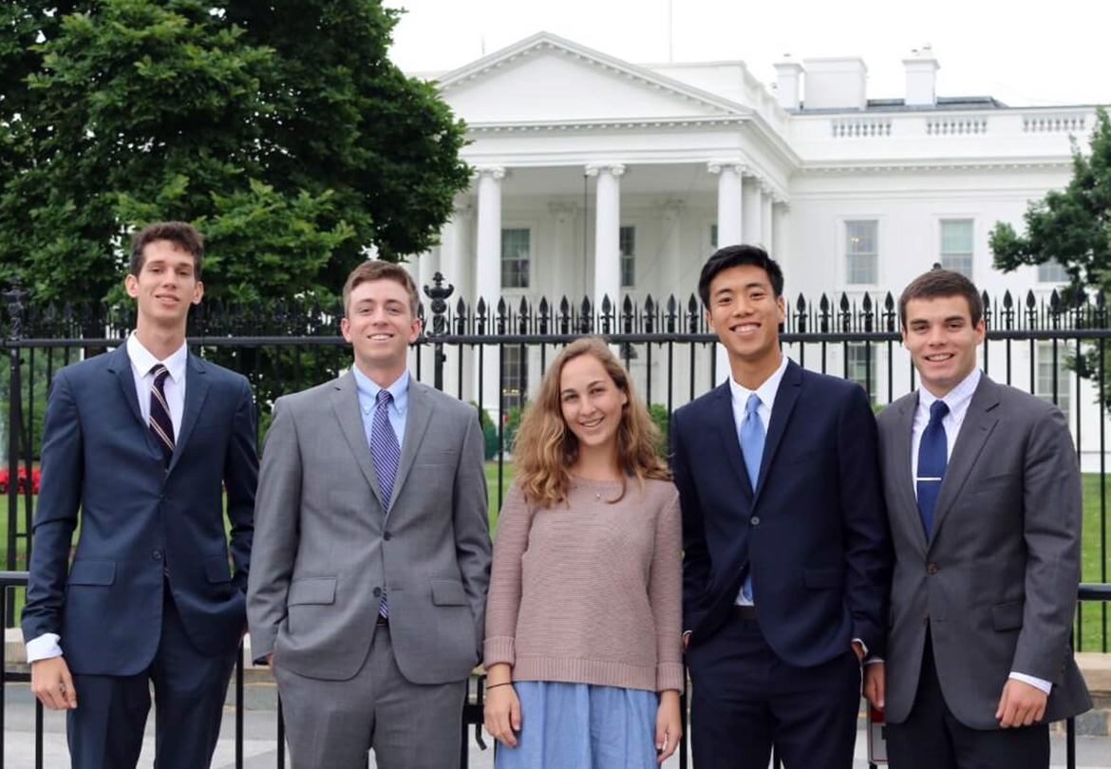  HOW TO APPLY  seminar Scholarships  Two Weeks in Washington!  - Contact your campus liaison  - (fill in with institutional step 2)  - (fill in with institutional step 3)  - All requests should be submitted by the posted deadlines.  For more information visit:  https://www.tbr.edu/washingtoncenter  https://www.twc.edu/find-program | Inside Washington Seminar  ────  January 6-19, 2019  National Security Seminar  ────  May 2019  ────  First come, first served!  Apply today!  CONTACT  Campus Liaison Name  Office  Telephone  Email  