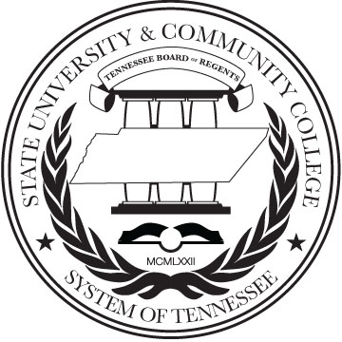  


*Office of Academic Affairs*

1415 Murfreesboro Road, Suite 324 | Nashville, TN 37217-2833| Phone 615.366.4482 | Fax 615.366.3903 | www.tbr.edu

On September 17 & 18, 2014, the Tennessee Board of Regents hosted the first Accessible Instructional Materials and Technology Summit. The Accessibility Summit, presented in collaboration with and support from the University of Tennessee system, brought together national figures in accessibility issues including Eve Hill, Deputy Attorney General for the Civil Rights Division, US Department of Justice; Dan Goldstein, Counsel for the National Federation of the Blind; Scott Lissner, President of the Association on Higher Education and Disability; Tim Creagan, Senior Accessibility Specialist with the US Access Board; and Ron Stewart, Managing Consultant with Altformat Solutions as featured speakers and panelists. These speakers addressed our obligations for accessibility to electronic and digital instructional information and to address these obligations in a proactive, effective manner. In addition, their presentations, discussions and Q & A sessions with the audience informed and reinforced the work of the THEC Task Force on Accessibility.

Other presenters included Jamie Principato, a disabled student from Arapahoe Community College, and Joe Shaw with the Tennessee Federation of the Blind. Both provided powerful insights and poignant stories of their challenges and successes.

The two-day event was designed for a spectrum of stakeholders in Tennessee higher education from senior administrators to functional staff personnel. Over 230 participants attended the Accessibility Summit including THEC, TBR and UT system executives, members of the THEC Task Force on Accessibility, TICUA leaders and a spectrum of TBR and UT institutional representatives including presidents, provosts, vice presidents, faculty leaders, purchasing officers, university/college counsel, online course developers, web designers, library directors, and disability services staff.

A significant focus of the Accessibility Summit was on how to develop system-wide and institutional plans for accessibility to instructional materials and technology and how Tennessee higher education systems and institutions can work collaboratively to address those expectations. Outcomes of the event include the development of a web-based accessibility tool box and a structured approach to addressing accessibility to instructional materials throughout higher education institutions and systems in Tennessee.